

**A211 STIA1113 – PROGRAMMING 1 (GROUP C)**

**ASSIGNMENT 3**

**NAME: NOR AISYAH BINTI ABD HALIM**

**MATRIC NUMBER: 286982**

**TOPIC: BANK**

**SUBTOPIC: BUSINESS LOAN**

**LECTURER: PROF. MADYA DR. AZMAN B YASIN**

**DUE DATE: 29 JANUARY 2022**

1. **Identify the problem**

Small and mid-size enterprises (SMEs) are businesses that maintain [revenues](https://www.investopedia.com/terms/r/revenue.asp), [assets](https://www.investopedia.com/terms/a/asset.asp) or a number of employees below a certain threshold. Each country has its own definition of what constitutes a small and medium-sized enterprise (SME). Certain size criteria must be met and occasionally the industry in which the company operates in is taken into account as well.

SME finance is the funding of small and medium-sized enterprises, and represents a major function of the general business finance market – in which capital for different types of firms are supplied, acquired, and costed or priced. Capital is supplied through the business finance market in the form of bank loans and overdrafts; leasing and hire-purchase arrangements; equity/corporate bond issues; venture capital or [private equity](https://en.wikipedia.org/wiki/Private_equity); asset-based finance such as [factoring](https://en.wikipedia.org/wiki/Factoring_(finance)) and [invoice discounting](https://en.wikipedia.org/wiki/Discounting), and government funding in the form of grants or loans.

The SME Loan provides a single line of credit for meeting the borrowing needs of SME. It can be used as a working capital as well as for long-term requirements. It is approved after considering the nature of business, cyclical trends, cash flow projections, and peak time requirements.

Maybank is [Malaysia](https://en.wikipedia.org/wiki/Malaysia)'s largest bank by market capitalisation and total assets and [one of the largest banks in Southeast Asia](https://en.wikipedia.org/wiki/List_of_largest_banks_in_Southeast_Asia), with total assets exceeding US$203 billion and having a net profit of US$1.98 billion for 2019.

Maybank is also ranked 106th in The Banker's 2020 Top 1000 World Banks (as at July 2020) and is ranked 349th in the Forbes Global 2000 Leading Companies (as at May 2020).

Maybank is the largest public listed company on Bursa Malaysia, the Malaysian stock exchange, with a market capitalisation of US$23.7 billion as of 31 December 2019.

* Information:

1. Eligibility:
2. Below RM25 million annual sales turnover
3. Below RM5 million outstanding loan/ financing with Maybank
4. Malaysian-owned registered company

|  |  |  |
| --- | --- | --- |
|  | Online Application | Branch Application |
| Financing amount | RM10,000 – RM250,000 | RM50,001– RM1,500,000 |
| Financing tenure | Up to 5 years | Up to 7 years |
| Business operation period | Minimum 1 year | Minimum 3 years |

Calculation:

Monthly payment:

Using formula: $\frac{P * i}{1 - \frac{1}{{(1 + i)}^{n * 12}}}$

where

P = loan amount

i = monthly interest in decimal

n = loan term in years

1. **Understand the problem**

Due to Covid-19 pandemic, most of business person having trouble with money because they have to close the store. To prevent from bankruptcy, most of them want get a loan. Due to pandemic, everyone must stay at home and need to make an appointment first to walk into the branch. The customer has to wait until that day to go to the branch to get a loan and it will take a lot of time for them to get a loan.

1. **Identify alternative ways to solve the problem**
2. The system will give the main menu about Maybank and the customer has to enter the number based on the main menu to get information about it and the sysem will calculate the monthly payment for the customer.
3. The system will give information about loan and the customer will make a decision him/herself based on his/her eligibility.
4. **Select the best ways to solve the problem from the list of alternative solutions**

The system will give the main menu about Maybank and the customer has to enter the number based on the main menu to get information about it and the sysem will calculate the monthly payment for the customer.. The user will enter the information about him/herself (name, age, number phone) and about business loan ( loan amount and loan tunure) and the system will calculate the monthly payment.

1. **List instructions that enable you to solve the problem using the selected solutions**
2. Use the information from the customers.
3. The system will give the menu.
4. The information about SME Clean Loan will come out if the customer choose number 1.
5. If the customer want to know about type of application method, the customer will choose number 2.
6. The detail information about application method will come out if the customer choose number 3.
7. To know information about interest rate, the customer will enter number 4.
8. If the customer choose number 5, the customer will enter information about business loan ( amount of loan and loan tunere) and the system will calculate monthy payment and total payment.
9. To view record or receipt, the customer will enter number 6.
10. The customer will choose number 7 to exit from the system.
11. **Evaluate the solution**

In the end by using the system will help the customer to be more understand about business loan and will be easier for the customer to get a loan. SME Clean Loan give many benefits to customer. First, it is easy & quick because nowadays it can be applied online or at branch. Other than that, it has low rates and charges. It is also didn’t need collateral to apply loan. Monthly payment is calculated to help the customer experiment with different loan amounts and loan durations so they can figure out the suitable loan amount they would be able to take out without causing any inconvenience to their finances, and the period of time within which they can comfortably repay the loan.

1. **Algorithm**
2. Start
3. Display main menu.
4. Enter 1 will display information about SME Clean Loan.
5. Enter 2 to know types of application method.
6. Enter 3 to know further information about types of application method.
7. Enter 4 will display interest rate.
8. Enter 5 to input information.
9. Enter name, phone number and number account.
10. Enter outstanding loan with Maybank (if any).
11. Enter the number of loan that have make before (if any).
12. Enter the amount of loan (if any).
13. Enter business operation period and annual revenue.
14. Enter amount of loan and loan tenure.
15. System calculate the the monthly payment and total payment.
16. Enter 6 to view record or receipt.
17. Display name, phone number, number account, monthly payment and total payment.
18. Enter 7 to exit.
19. End
20. **Pseudocode**

Start

function displayMenu ( ) {

Display main menu

Output “ Please choose one of the above options: ”

Input choice

end function

}

function Information ( ) {

Display information about SME Clean Loan

Display eligibility

end function

}

function TypeApplication ( ) {

Display types of application method

end function

}

function ApplicationInformation ( ) {

Display information about online application

Display information about branch application

end function

}

function Interest ( ) {

Output "The interest rate is 4.5%."

end function

}

function Input ( ) {

do {

Output “Enter your name”

Input name [i]

Output “Enter your number phone”

Input number phone [i]

Output “Enter your account number”

Input account number [i]

Output “Do you have outstanding loan with Maybank ( 1 for yes | 2 for no):”

Input answer

If (answer = 1) Then {

Output "How many loan did you make before: "

Input loan

for (int k = 0; k < = loan; k++) {

Output “ Enter amount of ” + k + “ loan : ”

Input LoanAmount

total = total + LoanAmount

end for

}

}

If (total > 5000000) Then

Output "Sorry your outstanding loan is greater than 5 millions. You can't apply SME Clean Loan."

Else

Output "Enter business operation period (in months): "

Input period

Output "Enter your annual revenue: "

Input revenue

If ((period >= 12) && (revenue <= 25000000)) {

Output "Enter the amount of loan: "

Input amount [i]

Output "Enter financing tenure: "

Input tenure [i]

end If

}

calculatePayment( i )

Output “Monthly payment is RM’’ + monthlyPayment [i]

Output “Total payment is RM’’ + totalPayment [i]

Output “Record has been added successfully’’

Output “Do you want to add another input’’

Input choiceAdd

}

while ((choice == y ) || (choiceAdd == Y )

}

function CalculatePayment (int index) {

Calculate monthly payment = amount * (interest / 12) / ( 1 - 1 / (1 + (interest / 12 $)^{ duration * 12}$

Calculate total payment = monthly payment * 12 * duration

end function

}

function ViewRecord ( ) {

Display name

Display number phone

Display account number

Display monthly payment

Display total payment

End function

}

function main {

Output “ Welcome to Maybank ’’

do {

displayMenu ( )

switch (choice) {

case 1: Information ( );

break

case 2: TypeApplication ( );

break

case 3: ApplicationInformation ( );

break

case 4: Interest ( );

break

case 5: Input ( );

break

case 6: ViewRecord ( );

break

case 7: exitSystem ( )

break

while (choice != 7)

End while

function exitSystem ( ) {

Output “You choose to exit’’

Output “ Thank you for using this bank service’’

End

1. 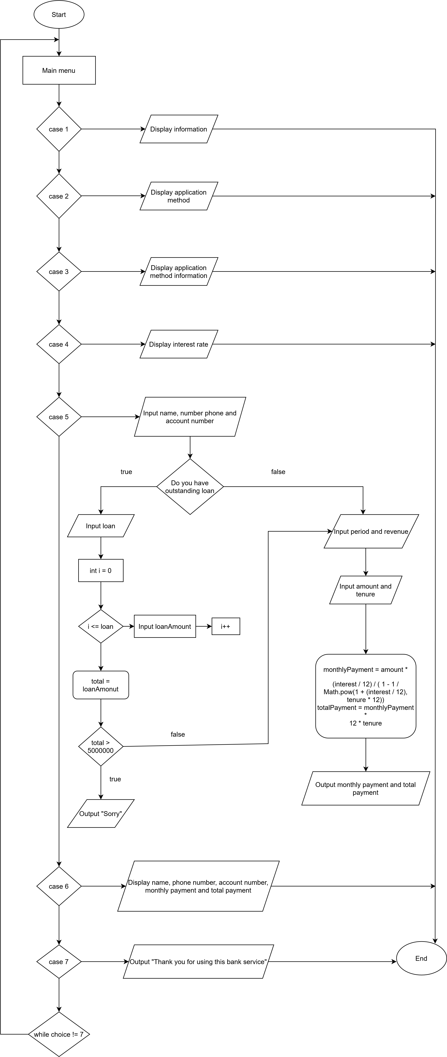**Flow Chart**
2. **Coding – Numerical Computation & Expression**
3. Coding

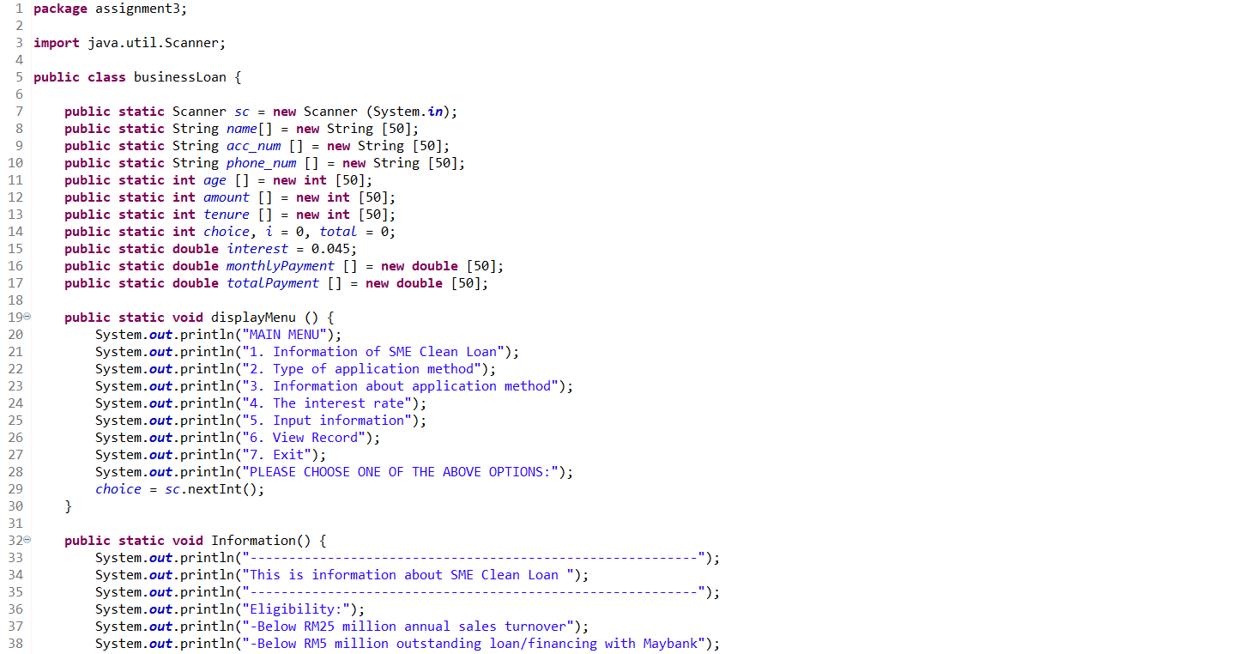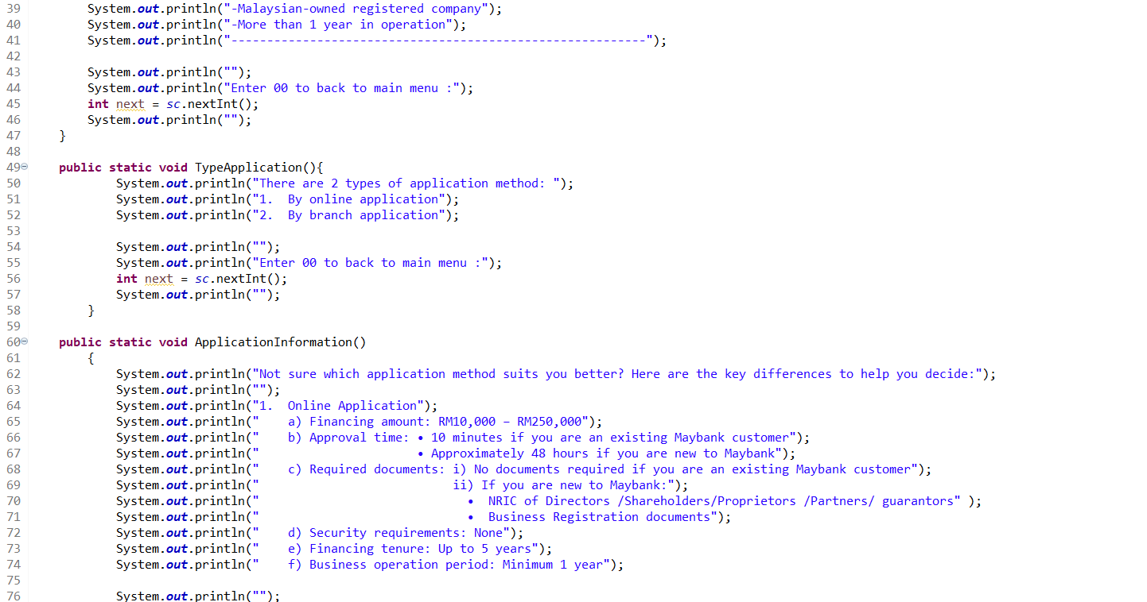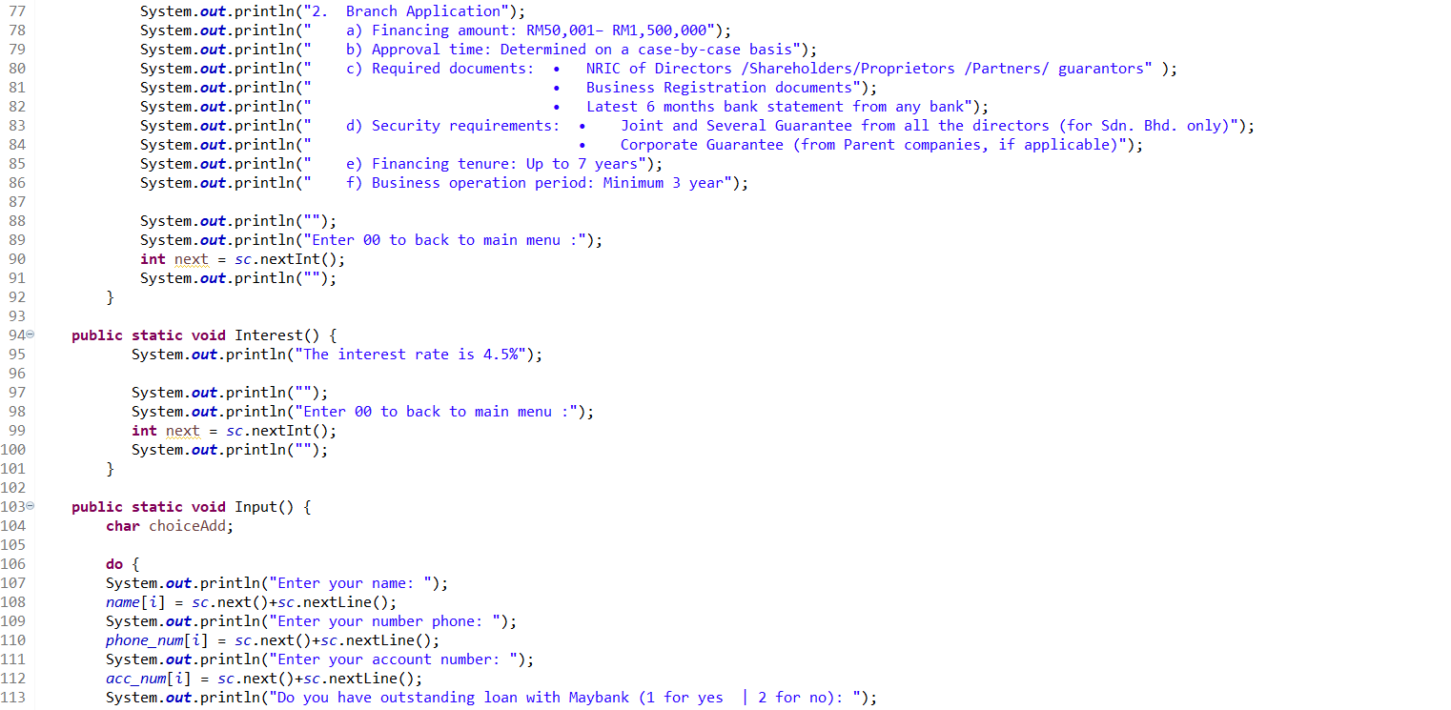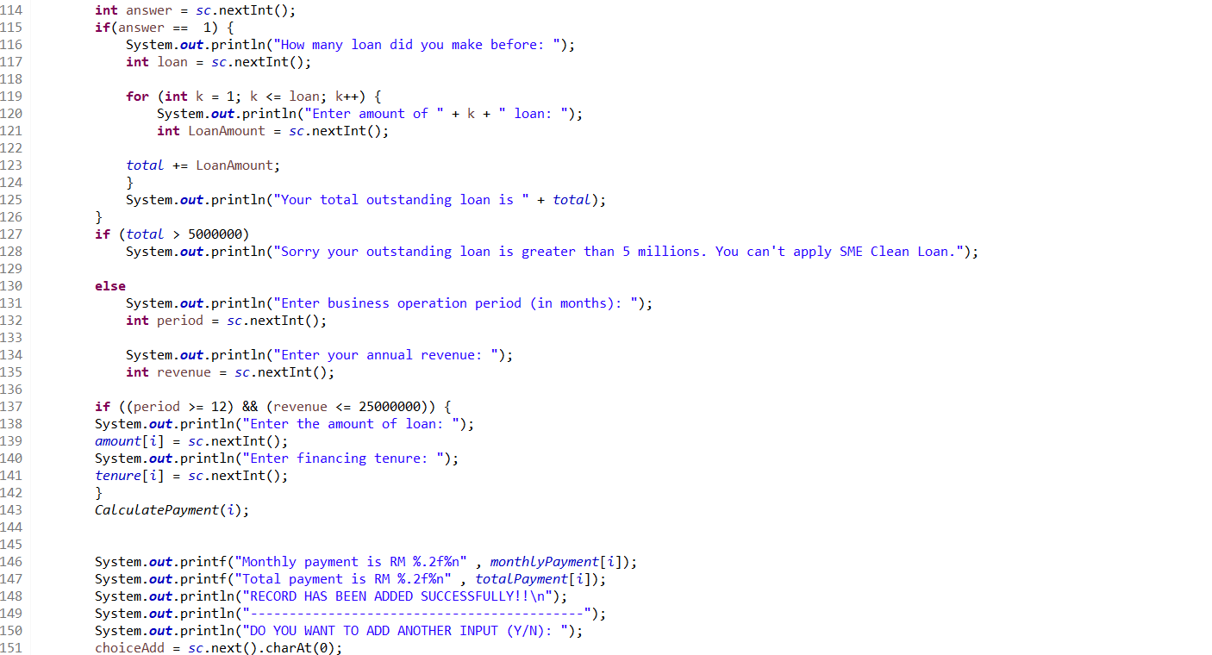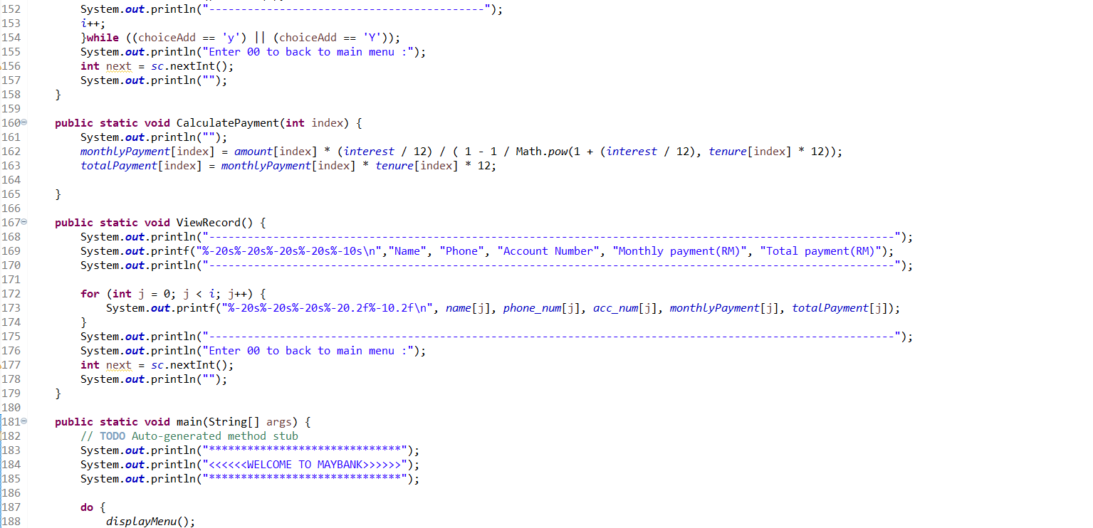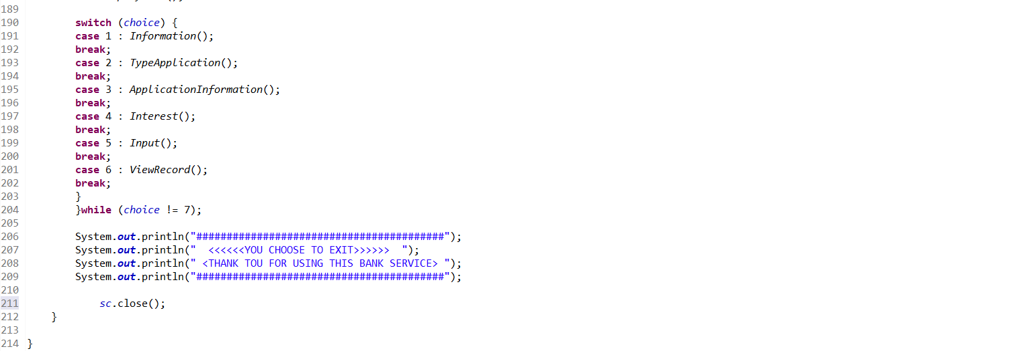

1. Output

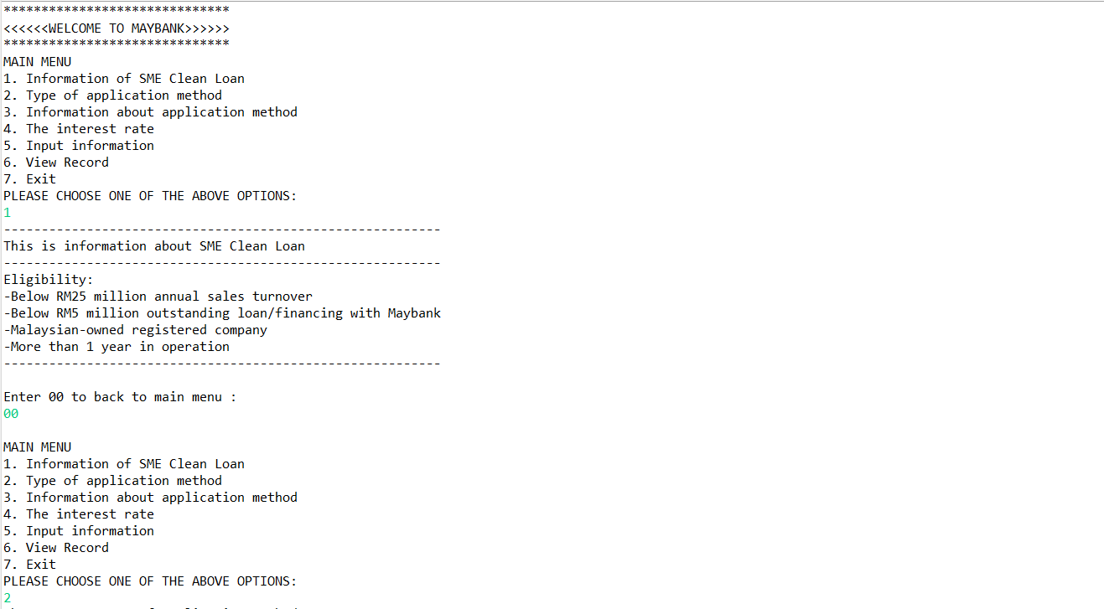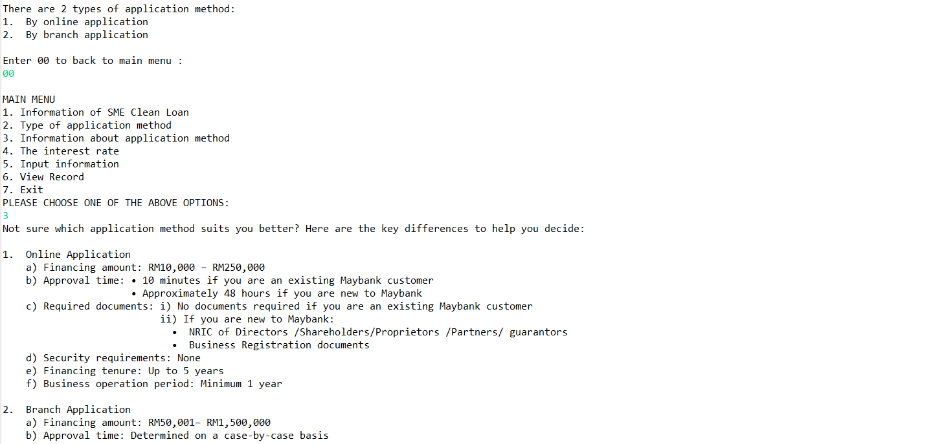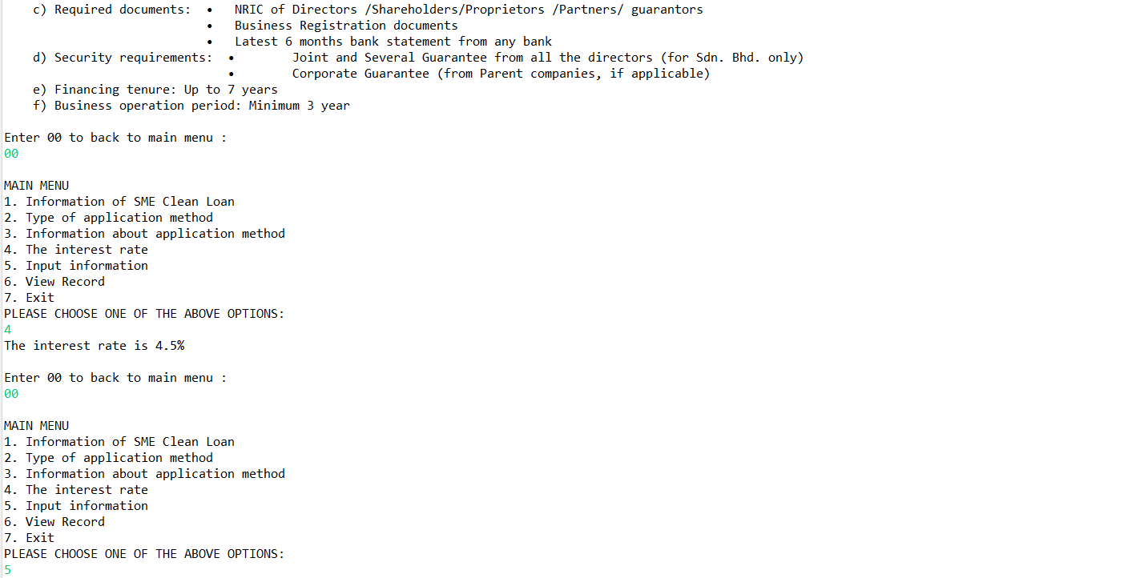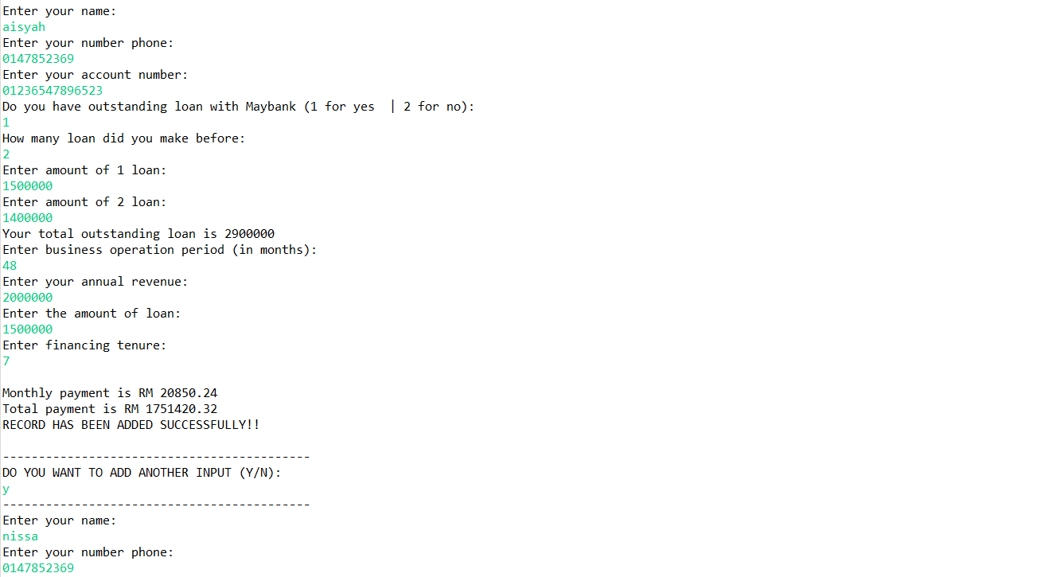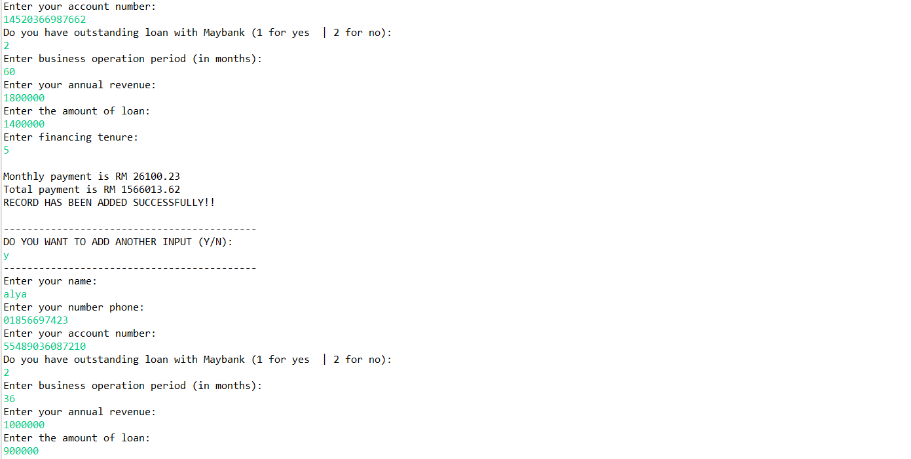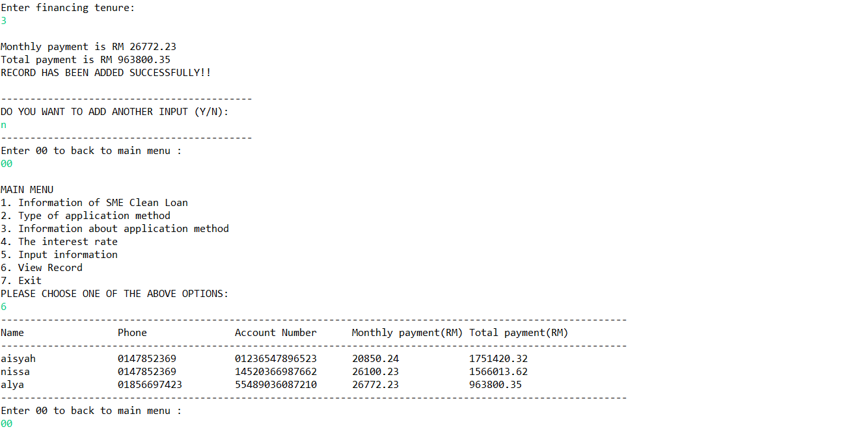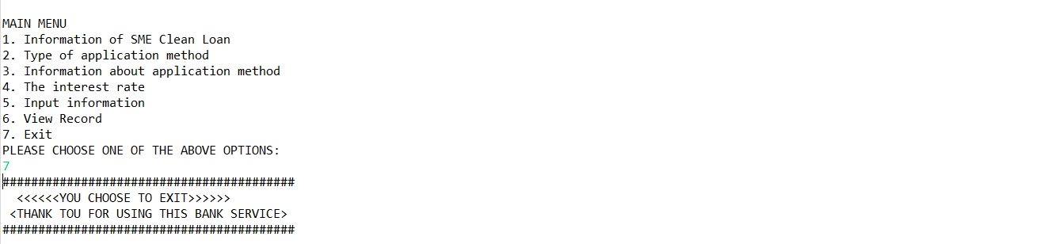



**A211 STIA1113 – PROGRAMMING 1 (GROUP C)**

**ASSIGNMENT 3**

**NAME: NUR ANIS SHAFIQAH BINTI MAZLAN**

**MATRIC NUMBER: 286987**

**TOPIC: BANK**

**SUBTOPIC: PERSONAL ACCOUNT**

**LECTURER: PROF. MADYA DR. AZMAN B YASIN**

**DUE DATE: 29 JANUARY 2022**



Since July 1983, Bank Islam Malaysia Berhad has been operating as an Islamic bank in Malaysia. Bank Islam is Malaysia's first Islamic bank, and it has played a significant role in the creation and growth of the country's Islamic financial system. Our current existence is focused on satisfying society's financial demands in the most sustainable and ethical way possible, while adhering to Shariah regulations and principles.

1. **Identify the problem:**

Encik Karim, a retired teacher from SMK Kubang Kerian, was 62 years old. Encik Karim wanted to pay his electric bill at Bank Islam Kubang Kerian in Kota Bharu, Kelantan, last week. Encik Karim was having problems transferring money to Tenaga Nasional Berhad for pay his house electric bill during the COVID-19 epidemic because people were advised to stay at home to prevent getting the virus. Encik Karim is looking for a solution from Bank Islam Malaysia to help him in paying his electric bill.

1. **Understand the problem:**

Our goal at Bank Islam is to create alternatives for everyone and improve their lives. We accomplish this through offering end-to-end financial systems that fit the various requirements of customers, as well as a platform for our stakeholders to grow, including our people, customers, and community.

According to the problem stated, Encik Karim is having problems paying a bill since he is unable to go to Bank Islam. This implies Encik Karim will have to find another way to pay his electric bill without having to go to Bank Islam.

1. **Identify alternative ways to solve the problem:**
2. Create an online service programme (GO Bank Islam) that requires customers to provide their information and allows them to transfer money via phone or laptop.
3. Contact Bank Islam employees and request that money be transferred by providing customer information.
4. **Select the best way to solve the problem from the list of alternative solutions:**



The first way is the best way that can be easier for Encik Karim to transfer his money. GO Bank Islam online service program can assist customer with their problems relating to the option that are available. A program will provide user information related to Recipient Bank, Recipient Account, Recipient Name, Recipient Reference, Amount. This program will lead the user through the process of transferring money and will calculate the total amount transmitted and any fees that may be charged based on the user's request.

1. **List instructions that enable you to solve the problem using the selected solution:**
2. User need to choose DuitNow.

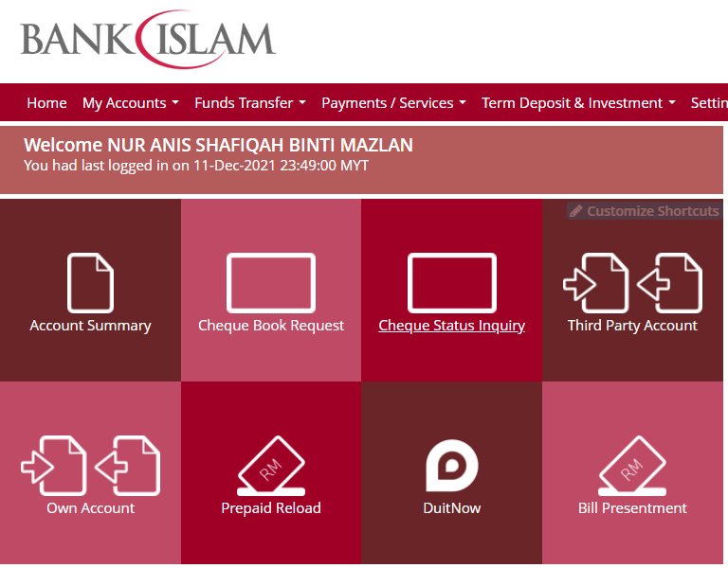

1. Ask user to key in their account number .

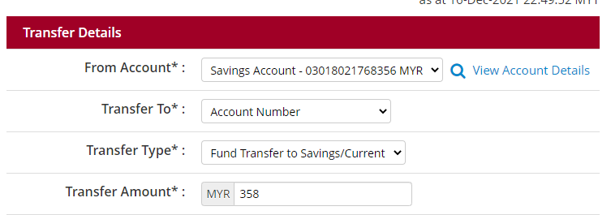

1. The program will display the details needed. (example: Recipient Bank Name, Recipient Account, Recipient Name, Recipient Reference, Amount ).

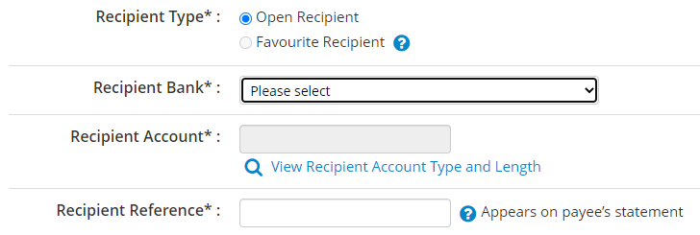



1. Ask user to key in the information needed.
2. The program will calculate the total amount transmitted and fees that have been charged.
3. The program will display the total amount transmitted and fees that have been charged to user.

EXAMPLE :

Account number : 764538

|  |  |  |
| --- | --- | --- |
| OPTION |  | FORMULA |
| DuitNow | Recipient Bank Name : Bank Muamalat  Recipient Account : 63518028  Recipient Name : Salman Bin Aziz  Recipient Reference : For food  Amount : RM176.00  *RM1.00 will be charged.  *Fee = 2% | RM176.00 + RM1.00 + (RM176.00*0.02)  = RM180.52 |

1. **Evaluate the solution**

Based on the solution that have been stated, Encik Karim can pay his electric bill by using GO Bank Islam services and choose DuitNow to transfer the money. Besides, regarding to the situation that Encik Karim or people who need to transfer their money but need to stay at home, also can make transaction money to others by using DuitNow too. They can use it on their phone or laptop at anywhere and anytime.

1. **Algorithm**
2. User need to choose option given.
3. Choose option 1 for register as new user.
4. Insert user full name, account number and phone number.
5. User become a new member of GO Bank Islam.
6. User need to choose option given.
7. Choose option 2 for making transaction using DuitNow.
8. Insert user account number, recipient bank name, recipient account number, recipient name, recipient reference and amount.
9. Wait until programme finish calculate total amount and fee that been charged.
10. Programme display total amount and fee that been charged.
11. Programme will ask if user want to make another transaction.
12. If yes, user need to insert the new information details.
13. If no, user will return to the list option.
14. User need to choose option given.
15. Choose option 3 for exit.
16. User will exit from the programme.
17. **Pseudocode**

start

do

read choose

switch(choose)

case 1 : array user

call method Register(user)

break;

case 2 : array DuitNow

call method Duitnow(DuitNow)

break;

case 3 : array exit

call method exitSystem(exit)

break;

end while (choose!= 3)

end

method Register(user)

declare name array size=15

declare acc_number array size = 15

declare phone_number array size = 10

initialize a = 1

read name,acc_number,phone_number

end

method Duitnow(DuitNow)

initialize addedTime=0

declare addtransaction=‘X’, back=‘X’

initialize length=10

declare acc array size=length

declare amount1 array size=length

declare acc1 array size=length

declare bankname1 array size=length

declare name1 array size=length

declare reference1 array size=length

read anotherBank

start for from 0 to length

declare i = addedTime

read acc,bankname1,acc1,name1,references1,amount1

read next1,anotherBank1

calculate total1=array amount1+((array amount1*0.02)+1)

display total1

addedTime=addedTime+1

read addtransaction

if(addtransaction == ‘N’|| addtransaction == ‘n’)

back =‘y’

declare i=length

end if

end for

end

method exitSystem(exit)

end

1. **Flowchart**

end while

(choose!=3)

call method

exitSystem(exit)

break;

call method

Duitnow(DuitNow)

break;

call method

Register(user)

break;

case 1 : array user

case 3 : array exit

case 2 : array Duitnow

do

read choose

switch (choose)

declare name

array size=15

read name,acc_number,phone number

int a=1

declare phone_number

array size=10

declare acc_number

array size=15

declare acc

array size=length

declare amount1

array size=length

declare acc1

array size=length

declare bankname1

array size=length

declare name1

array size=length

declare reference1

array size=length

int i=0

int length=10

declare addtransaction=‘X’,back=‘X’

int addedTime=0

i<lenght

T

T

if(addtransaction==‘N’||addtransaction==’n’)

F

i=length

back=‘y’

read transaction

addedTime=addedTime+1

display total1

read next1,anotherBank1

calculate total1=

array amount1+((array amount1*0.02)+1)

read acc,bankname1,acc1,name1,reference1,amount1

declare i=addedTime

1. **Coding**

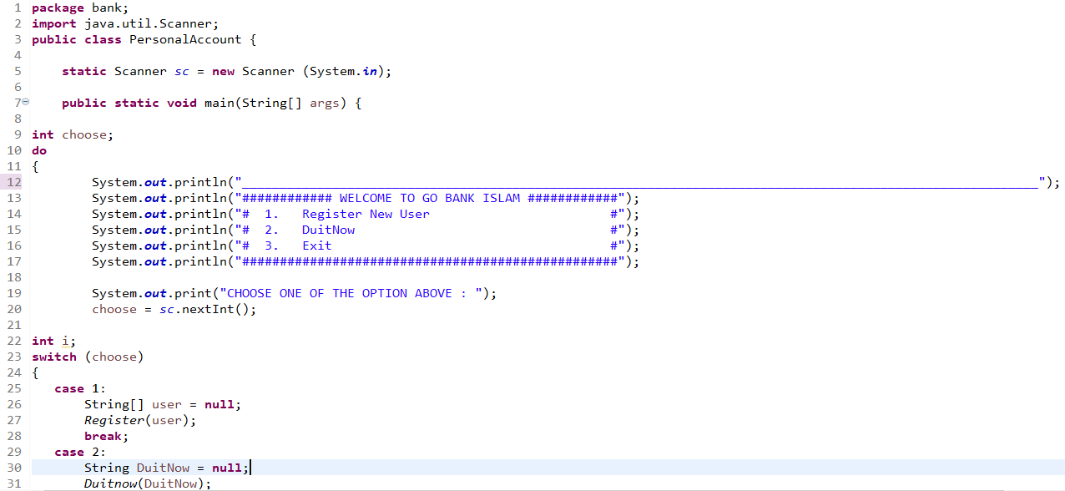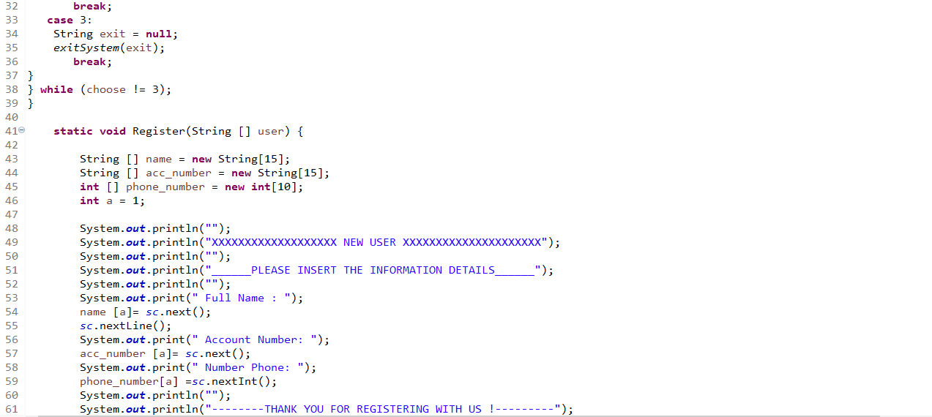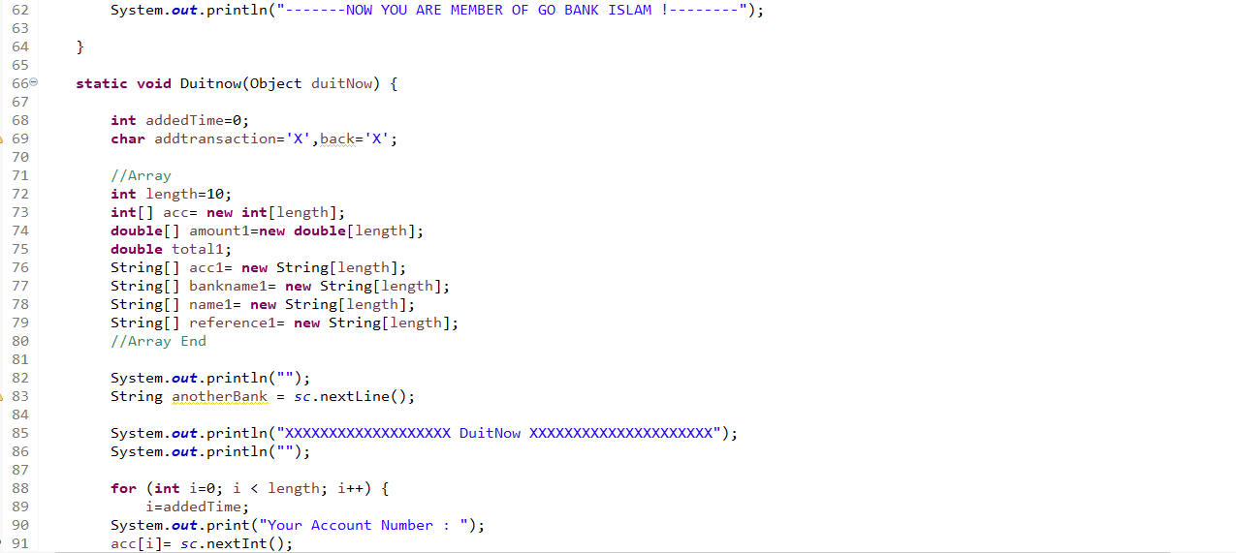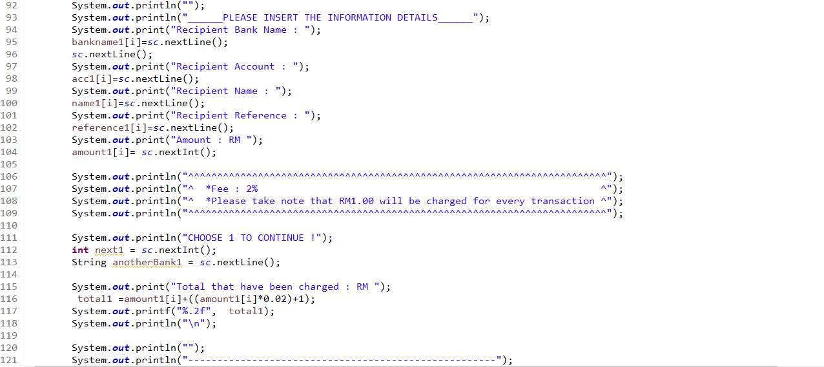

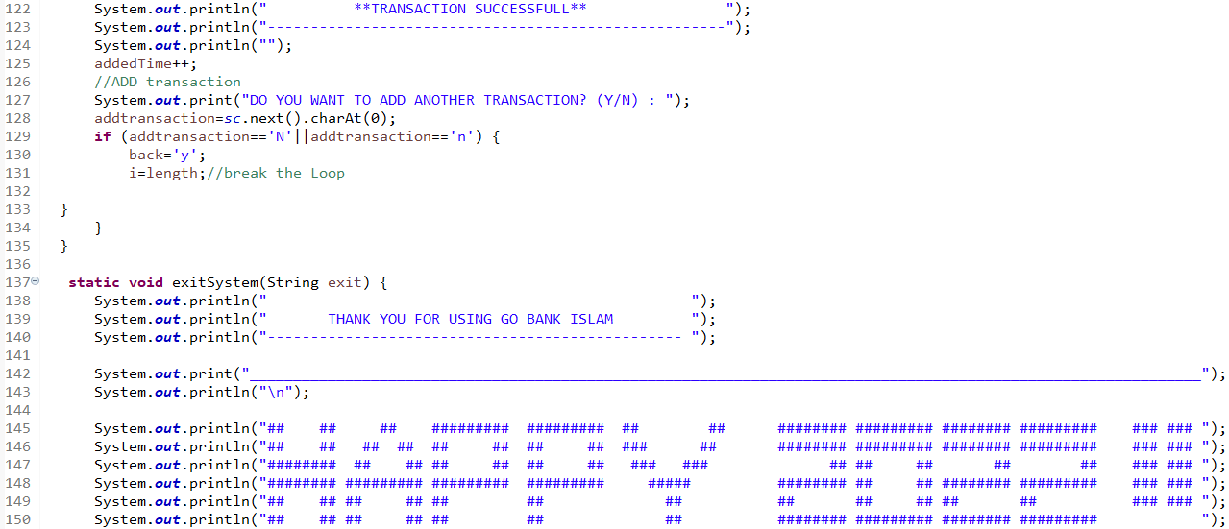

OUTPUT :

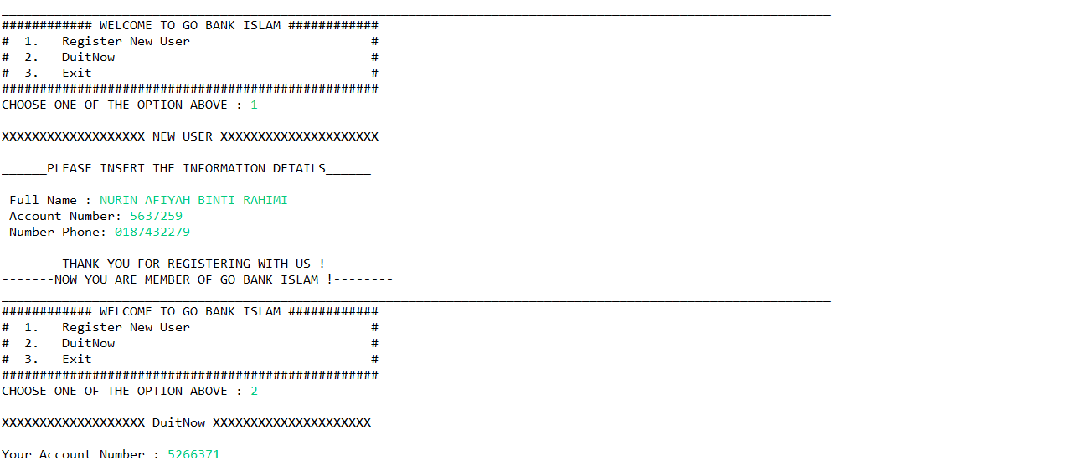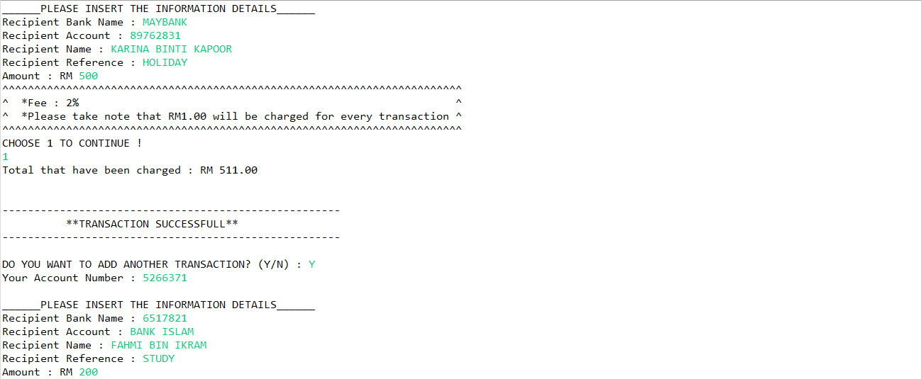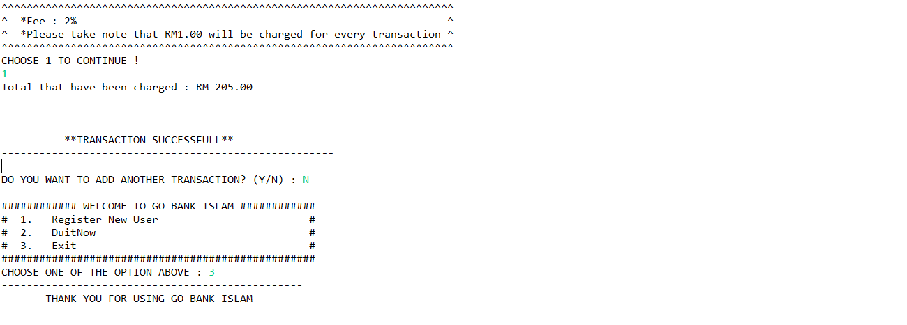

**ASSIGMENT 3:**

**THE UTILITY OF CREDIT CARD**



NAME: MUHAMMAD AFIQ IMRAN BIN AZIZAN

MATRIKS NO.: 286997

UNIVERSITY: UNIVERSITY UTARA MALAYSIA

CLASS: INFORMATION TECHNOLOGI, SCHOOL OF

COMPUTING

LECTURER: PROF. MADYA DR.AZMAN B YASIN

DUE DATE: 12 DECEMBER 2021

**History:**

Credit Card is a plastic containing a means of identification that could make purchase of goods and service with lending money from bank. Credit Card first invented at United State of America in 1920s because it bother company that customer purchase made by company outlets. In 20th century the uses of credit card increasing and almost all people such as university student, teacher, and worker have credit card of their own.

**PROBLEM:**

In today era credit card is necessary to have for everyone to buy certain stuff without using cash. Even so you can’t go out because of covid 19 hit every country and everyone need to stay at home. Thuse making it hard for everyone to buys things, pay debt, buy airplane ticket for future use and many more. Not only that, we need to buy things faster without wasting much time to go many places. Furthermore, you want to get prize when you buy things you want, Lastly, you want to know how much you need to pay for things you buy.

**UNDERSTANDING THE PROBLEM:**

The problem that you facing is that we can’t go out to buy things without breaking the law. This is because you didn’t want to get infected by covid 19. Another one is, you don’t want to go to many places. This is because when you go many places it can waste many times, energy and money. Third one is you want to get prize when buy things. This is because it can make you want to buy things more. Lastly, you want to know how much money you will get back after pay for month. This is because we can know how many money you want to pay up.

**ALTERNATIVE TO SOLVE PROBLEM:**

The alternative is to make program for people to use for buying, getting gift and calculate payment. Other than that we can wait until covid is calm down so that we can go out without getting in trouble.

**BEST ALTERNATIVE:**

The best alternative to solve this problem is using the first solution, making program about credit card for people to use. Reason are that the program can be use everywhere and anytime. Not only that it helps a lot for people who want to done things in one setting. Thus that’s why the first alternative is the best one.

**INSTRUCTION:**

1. Enter your name

* Enter payment for thing you want to buy
* Choose what credit card you want to use
* The program will calculate balance for credit card
* The program will calculate cashback (if have)
* Enter current money
* The program will calculate monthly debt and money left

1. Gift shop

* Choose 3 item from gift shop

1. Calculator to find balance for 1 month

* Enter probability

(this will do many time base on how many probability you want to see)

* Enter investment for credit card
* Enter annual interest rate
* Enter payment you want to make
* This program will calculate the interest, paid amount and balance

**TYPE OF CREDIT CARD:**

|  |  |  |  |  |
| --- | --- | --- | --- | --- |
| Type of credit card | Name of credit card | Specialty | picture | Interest rate |
| Type 1 | CIMB e Credit Card | none |  | 15% |
| Type 2 | CIMB Petronas Platinum MasterCard | -Give cashback of 7% on petrol money |  | 15% |
| Type 3 | Bank Rakyat Platinum Explorer Credit Card-i | -Give cashback of 5% on airlines and hotel booking |  | 15% |

**CALCULATION:**

|  |  |  |
| --- | --- | --- |
| Type of credit card | calculation | Description |
| Type 1 | -smartphone = 200  -laptop = 3000  -petrol = 50  - airplaneTicket = 4556  -Insurance = 74  -houseDebt = 650  -carDebt = 494  -HotelBooking = 200  -Totalpayment = 2000 + 3000 + 50 + 2556 + 74 + 650 +  494  -monthly payment= (2000/12) + (3000/12) + (50/12) +  (2556/12) + (74/12) + (650/12) +  (494/12)  -current money = 2000  -new money = 2000 + 3500  Money left = new money – monthly payment | -Thers nothing special about credit card type A because it’s just a basic one |
| Type 2 | *same as Type A  -petrol cashback = 50 *0.07  -balance = petrol cashback + new money | -Credit Card Type B will give you back 7% of petrol money in a year |
| Type 3 | *same as Type A  -airplane ticket cashback = (airplane ticket * 0.05) (4)  -hotel booking cashback = ((hotel booking * 0.05) (4)(7))  -last balance = balance 8 + airplane ticket cashback + hotel booking cashback | - Credit Card Type C will give you back 5% of airplane ticket and hotel booking |

**CALCULATION CREDIT CARD WITH DEBT:**

Calculate in June

|  |  |  |
| --- | --- | --- |
| description | Interest rate | calculation |
| -you have amount of debt RM1000  -you spend 100 at June 10  -you spend 400 at June 20  -you spend 100 at June 30 | 20% | **Calculating DPR:**  -20/365 = 0.054%  **Monthly Interest Rate:**  0.054 * 30 = 1.62%  **June 1 – 9:**  1000 * 9 = 9000  **June 10 – 19:**  1100 * 9 = 9900  **June 20 – 29:**  1500 * 9 = 13500  **June 30:**  1600 * 1 = 1600  monthly interest rate = (9000 + 9900 + 13500 + 1600) / 30    = RM1133  **Rate:**  Rate = (1.62/100) * 1133  = 18.35 |

**GIFT SHOP:**

|  |  |
| --- | --- |
| Gift code | item |
| 1 | Samsung Smartphone |
| 2 | Trip to Langkawi |
| 3 | GCS Ticket Movie |
| 4 | PS4 |
| 5 | ASUS Laptop |

**CALCULATAION FOR MONTH PAYMENT:**

|  |  |
| --- | --- |
| Input | Calculation |
| -probability(how many you want to calculate)  -investment  -rate  -payment | percentage interest = (investment * rate) / 12  interest = (percentage investment)/ 100  paid amount = interest + investment  balance = paid amount - payment |

**Evaluate the solution:**

In conclusion, buy using credit card it can help you a lot with purchasing and pay things up in no time and make things easier for us to pay without going everyplace to get things done and waste our energy. I hope that technology in credit card will improve because it help a lot to people like us to do some payment and purchasing easier.

**ALGORITHM:**

**PSEUDOCODE:**

Start

Read  b, smartphone, laptop , petrol , airplaneTicket , Insurance , houseDebt , carDebt ,

HotelBooking, a, u, probability, investment, rate, payment

c=0

While (c < =100)

If(b==1)

Print “You choose credit card payment”

printcreditcard

C++

else if(b==2)

print “You choose gift shop”

printgiftshop

c++

else if(b==3)

print “You choose credit card calculator”

c++

else if(b==4)

print “thank you for using our program”

c = c + 200

else

print “ this command didn’t exist”

c++

printcreditcard

limit1 = 40000

limit2 = 80000

limit3 = 65000

Total payment = smartphone + laptop + petrol + airplaneTicket + Insurance +

houseDebt + carDebt +HotelBooking

SmartphoneDebt1 = (smartphone/12)

laptopDebt1 = (laptop/12)

petrolDebt1 = (petrol/12)

airplaneTicketDebt1 = (airplaneTicket/12)

InsuranceDebt1 = (Insurance/12)

houseDebt1 = (HouseDebt/12)

carDebt1 = (carDebt/12)

HotelBookingDebt1 = (HotelBooking/12)

AllDebt1 = SmartphoneDebt1 + laptopDebt1 + petrolDebt1 + airplaneTicketDebt1

+ InsuranceDebt1 + houseDebt1 + carDebt1 + HotelBookingDebt1

Output  AllDebt1

Debt1 = 1000 * 9

Debt2 = 6000 * 9

Debt3 = 7074 * 9

Debt4 = 7768 * 1

Currentmoney = 2000

NewMoney = Currentmoney + 3500

If (a==1)

Output “You choose CIMB e Credit Card”

Balance = limit1 – totalpayment

Output balance

If (a==2)

Output “You choose CIMB Petronas Platinum MasterCard”

Balance = limit1 – totalpayment

Cashback = (0.07/100)(petrol)

Balance2 = balance + Cahsback

Output balance, balance2

If (a==3)

Output “You choose CIMB e Credit Card”

Balance = limit1 – totalpayment

Cashback = (((0.05/100) * (airplaneticket)) + ((0.5/100) * (Hotelbooking))

Balance2 = balance + cashback

Output Balance, Balance2

Else

Output “Unknown Credit Card”

SmartphoneDebt1 = (smartphone/12)

laptopDebt1 = (laptop/12)

petrolDebt1 = (petrol/12)

airplaneTicketDebt1 = (airplaneTicket/12)

InsuranceDebt1 = (Insurance/12)

houseDebt1 = (HouseDebt/12)

carDebt1 = (carDebt/12)

HotelBookingDebt1 = (HotelBooking/12)

AllDebt1 = SmartphoneDebt1 + laptopDebt1 + petrolDebt1 + airplaneTicketDebt1

+ InsuranceDebt1 + houseDebt1 + carDebt1 + HotelBookingDebt1

Output AllDebt1

Debt1 = 1000 * 9

Debt2 = 6000 * 9

Debt3 = 7074 * 9

Debt4 = 7768 * 1

Currentmoney = 2000

NewMoney = Currentmoney + 3500

double MonthlyIntrestRate = DPR * 30

double rate = (MonthlyInterest/100) * MonthlyIntrestRate;

Output rate

double monthlydebt = AllDebt1 + rate;

Output monthlydebt

double moneyleft = newMoney - monthlydebt;

output moneyleft

t=3

while (t >0)

if (u == 1)

print “you choose Samsung Smartphone”

t--

else if (u ==2)

print “you choose Trip to Langkawi”

t--

else if (u==3)

print “you choose CGS Ticket Movie”

t--

else if (u==4)

print “you choose PS4”

t—

else if (u==5)

print “you choose ASUS laptop”

t—

else

print “the item didn’t have in the shop”

print “We hope you like our gift”

printcreditcardcalculator

for (ii=1, ii <= probability, i++)

percantageinterest = (investment * rate) / 12

interest = percantageinterest / 100

paidamount = interest + investment

balance = paidamount – payment

print interest, paidamount, balance

**FLOWCHART:**

b, smartphone, laptop , petrol , airplaneTicket , Insurance , houseDebt , carDebt , HotelBooking, a, u, probability, investment, rate, payment

limit 1 = 40000, limit 2 =80000, limit3 = 65000

c=0

While (c<=100)

false

true

true

If else ( b==1)

Print “You choose credit card payment”

Printcreditcard

c++

If else ( b==2)

false

true

Print “You choose gift shop”

Printgiftshop

c++

false

true

Printcreditcardcalculator

c++

Print “You choose credit card calculator”

If else ( b==3)

If else ( b==4)

false

true

Print “this command didn't exist “

else

c = c + 200

true

Print “thank you for using our program”

Printcreditcard

false

true

Output balance, Balance2

Output balance

Balance = limit2 – total payment

Cashback = (0.07/100) * (petrol)

Balance2 = Balance + Cashback

Output “You choose CIMB Petronas Platinum MasterCard”

false

else If (a==2)

true

Balance = limit1 – total payment

Output “You choose CIMB e Credit Card”

If (a==1

Total payment = smartphone + laptop + petrol + airplaneTicket + Insurance + houseDebt + carDebt +HotelBooking

false

else if (a ==3)

true

Output “You choose Bank Rakyat Platinum Explore Credit Card-i”

Balance = limit1 – total payment

Cashback = ((0.05/100) * (Airplaneticket)) +((0.05/100) * (HotelBooking))

Balance2 = Balance + Cashback

Output balance, Balance2

else

Output “Unknown Credit Card”

SmartphoneDebt1 = (smartphone/12)

laptopDebt1 = (laptop/12)

petrolDebt1 = (petrol/12)

airplaneTicketDebt1 = (airplaneTicket/12)

InsuranceDebt1 = (Insurance/12)

houseDebt1 = (HouseDebt/12)

carDebt1 = (carDebt/12)

HotelBookingDebt1 = (HotelBooking/12)

AllDebt1 = SmartphoneDebt1 + laptopDebt1 + petrolDebt1 + airplaneTicketDebt1

+ InsuranceDebt1 + houseDebt1 + carDebt1 + HotelBookingDebt1

Debt1 = 1000 * 9

Debt2 = 6000 * 9

Debt3 = 7074 * 9

Debt4 = 7768 * 1

MonthlyInterest = (Debt1 + Debt2 + Debt3 + Debt4)/30

DPR = 15/365

MonthlyIntrestRate = DPR * 30

rate = (MonthlyInterest/100) * MonthlyIntrestRate

monthlydebt = AllDebt1 + rate

moneyleft = newMoney - monthlydebt

Output rate, monthlydebt, moneyleft

Printgiftshop

t =3

false

true

Output “you choose CGS Ticket Movie”

false

If (u==3)

t--

true

Output “you choose Trip to Langkawi”

false

If (u==2)

true

t--

Output “you choose Samsung Smartphone”

If (u==1)

true

While (t > 0)

false

If (u==4)

t--

Output “We hope you like the gift”

false

true

Output “the item didn’t have in this shop”

false

else

t--

true

Output “you choose ASUS Laptop”

If (u==5)

true

t--

Output “you choose PS4”

Printcreditcardcalculator

false

For( ii = 1,ii <= probability, ii++)

true

PercantageInterest = (investment * rate) /12

Interest = (percantageInterest/100)

PaidAmount = interest + investment

balance = PaidAmount - payment

Print Interest, PaidAmount, balance

**CODING:**

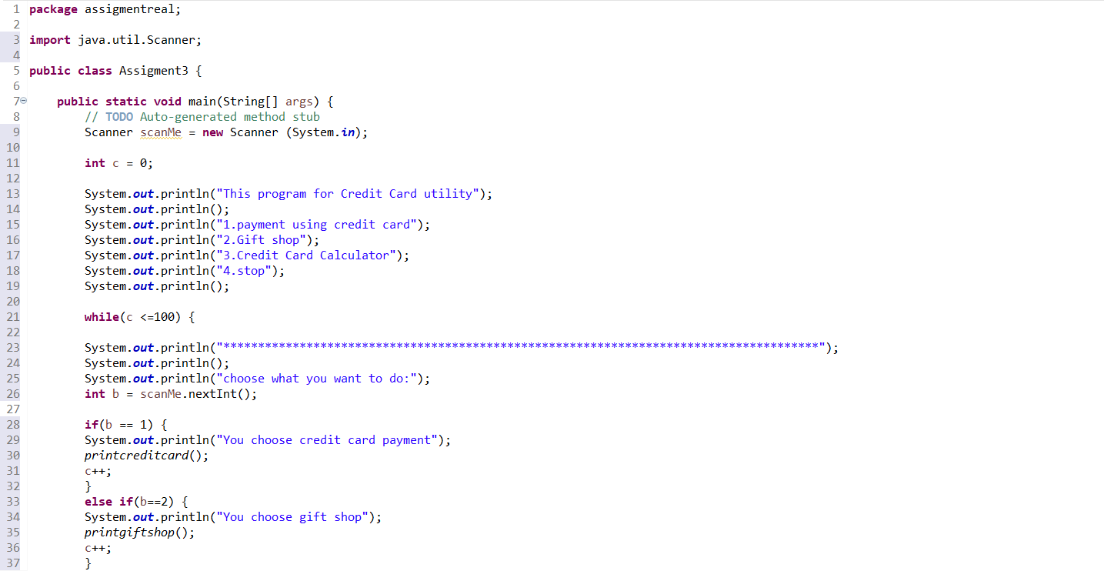

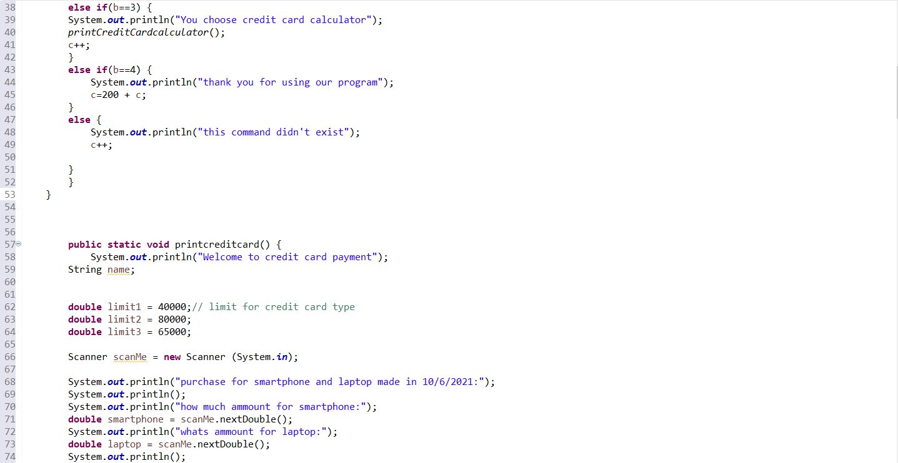

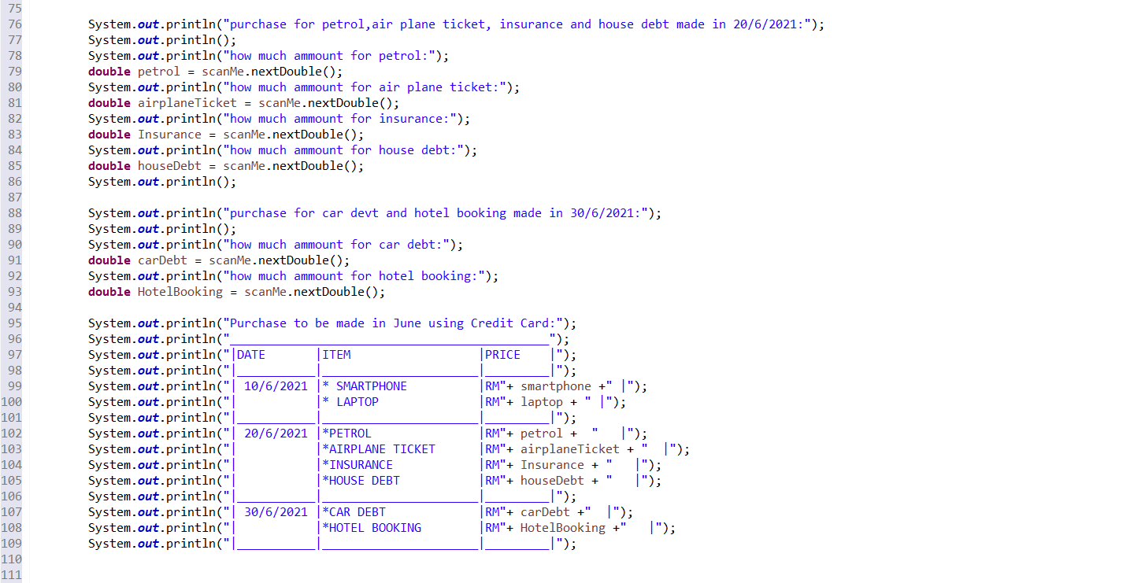

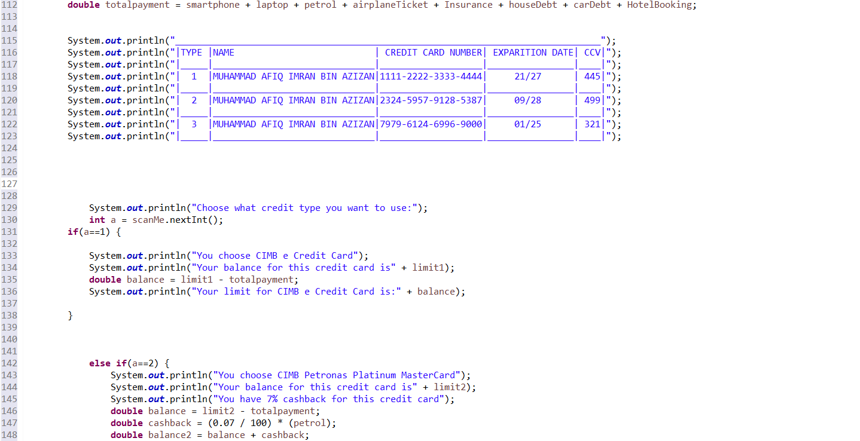

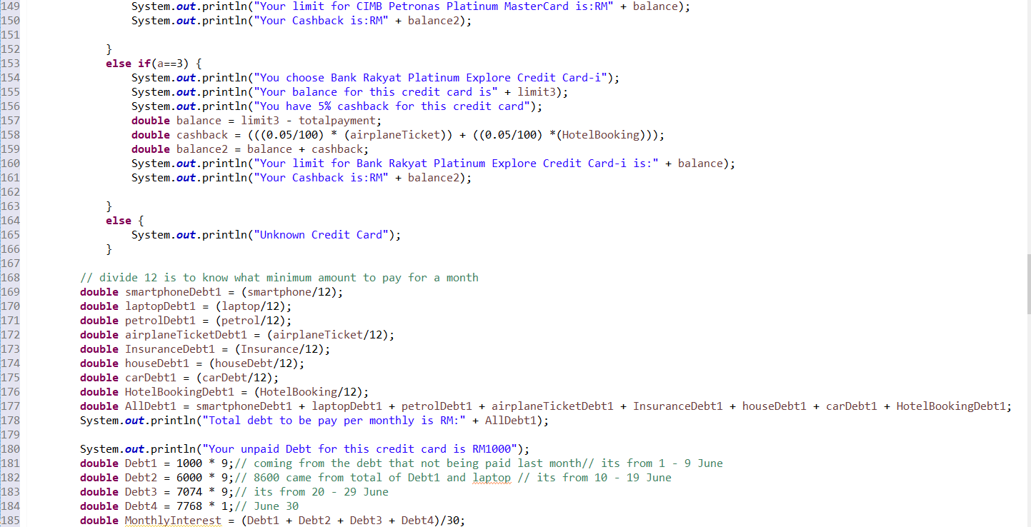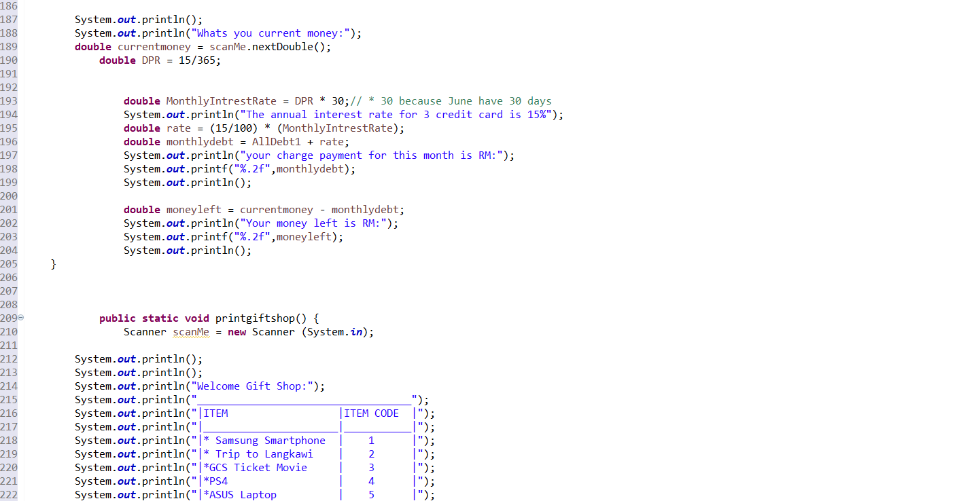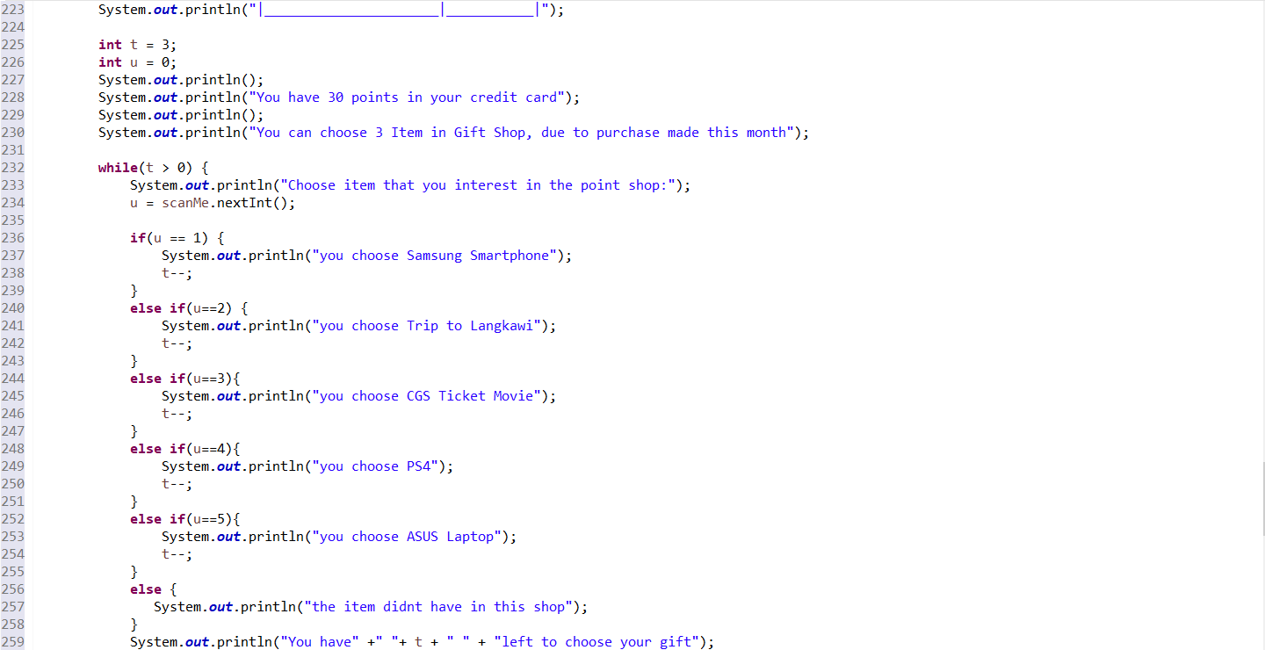

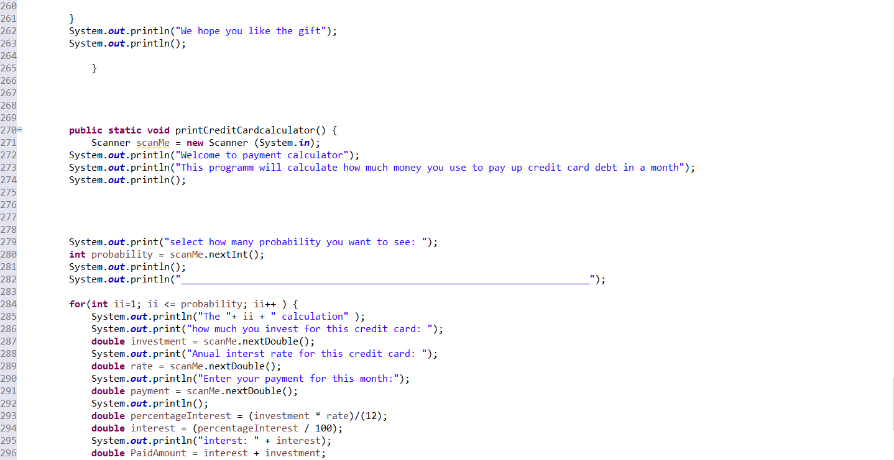

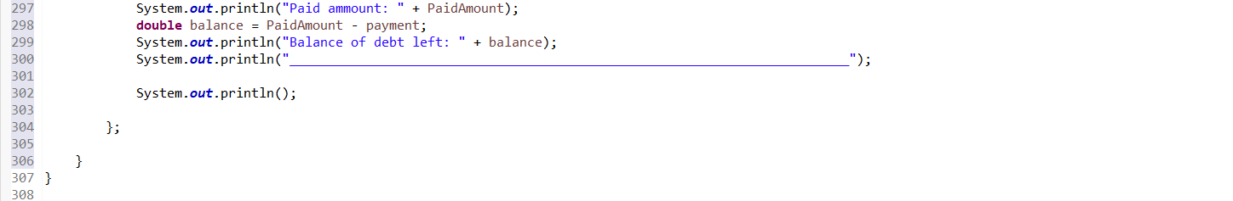**OUTPUT:**

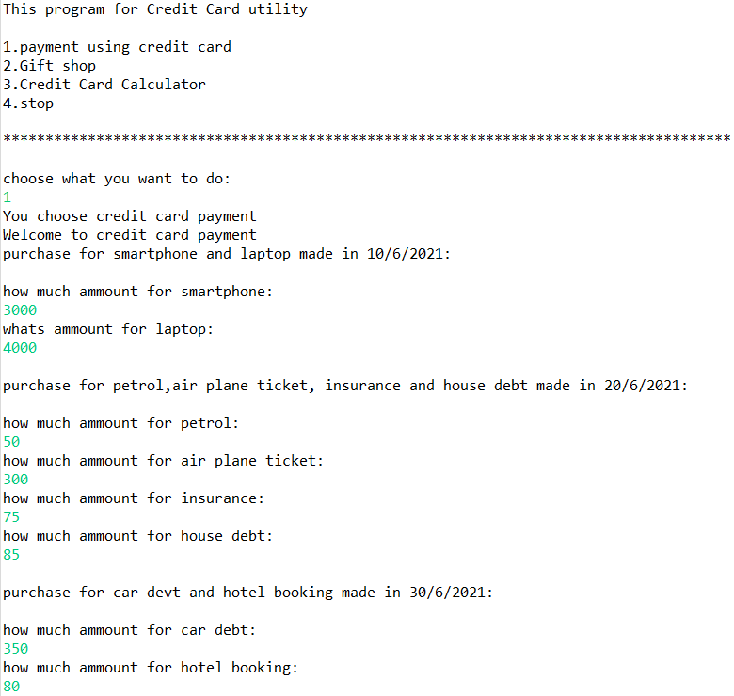

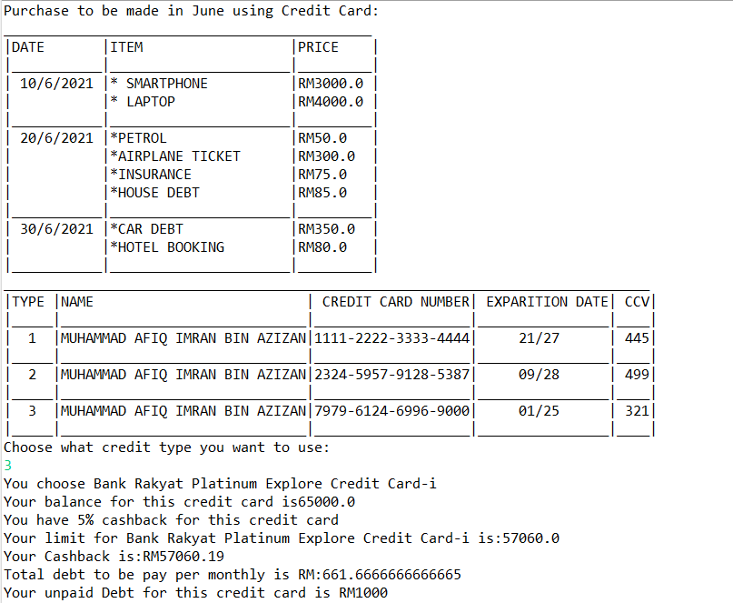

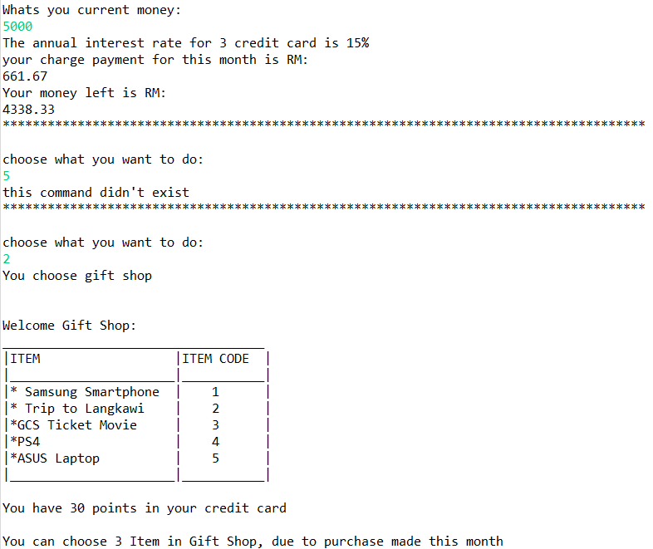

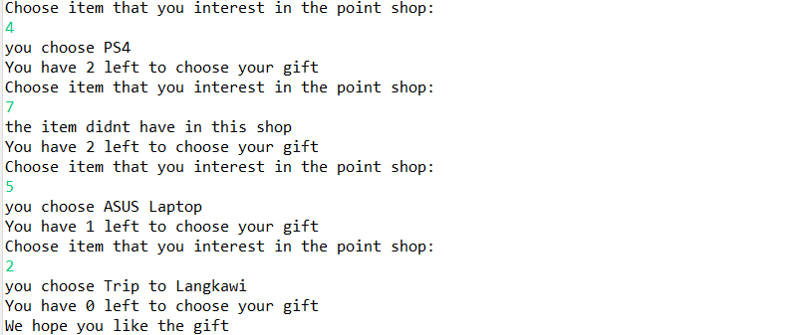

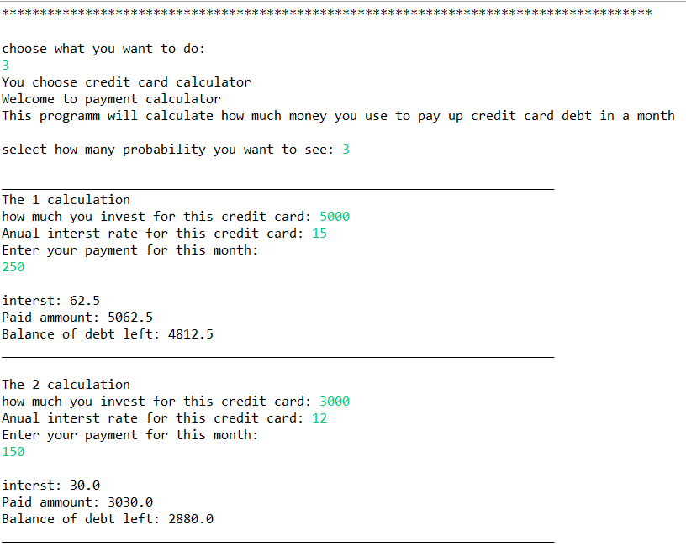

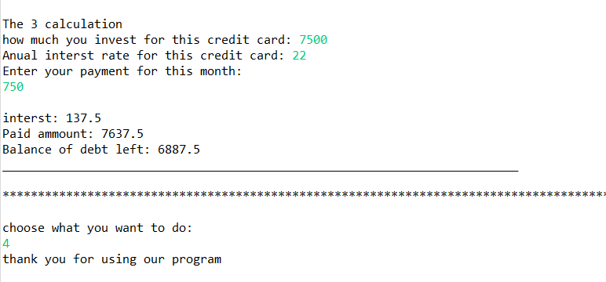



**A211 STIA1113 – PROGRAMMING 1 (GROUP C)**

**ASSIGNMENT 3**

**NAME: MUHAMMAD YASRI BIN ROSLAN**

**MATRIC NUMBER: 287021**

**TOPIC: BANK**

**SUBTOPIC: HOUSING LOAN**

**LECTURER: PROF. MADYA DR. AZMAN B YASIN**

**DUE DATE: 29 JANUARY 2022**

1. **Identify the problem**

A home loan also known as a mortgage is a contract between a borrower and a lender that allows the borrower to borrow money to purchase a home, apartment, condo, or other living property. A home loan is often repaid over 10, 15 or 30 years. The majority of people consider buying a home to be the most important financial decision they will ever make. Most people can't afford to pay cash for the entire property up front because residences can cost hundreds of thousands, if not millions, of dollars. As a result, they will need to obtain a house loan which borrow from a bank, credit union, or specialty mortgage lender for low-income borrowers such as CIMB Bank, Maybank or Bank Islam. For example Maybank is Malaysia’s largest financial services group and has a strong regional presence in South East Asia. Maybank offers a full range of financial products and services covering consumer banking, corporate and investment banking, Islamic banking, asset management, wealth management, insurance and takaful, and private banking. All of this is a importing thing to people to gain their loan to buy property or to invest for future. The situation that we can see is that new borrowers are hesitant to apply for a loan because they are unsure of how much they will have to pay if they apply for one and how much their entire total payment would be, including interest, throughout the life of the contract. Next the user also don’t know which one house that suitable with their budget and then they juts buy a house without thinking that price.

1. **Understand the problem**

Due to applicants' lack of awareness of the process, home loan applications in Malaysia have a high incidence of denial. According to Bank Negara Malaysia, home loan refusal rates reached nearly 60% last year (BNM). This is because many borrowers are uninformed of how much they can borrow and what they must remember to avoid their loan being rejected by the bank. This is a problem that many borrowers, particularly first-time borrowers, experience. The majority of them always apply for a loan based on the price of the home they want, but they overlook variables such as the amount they must repay. This is critical because when a borrower purchases a home without first calculating the amount they must repay, it can cause certain borrowers to have difficulty repaying their loans, and in some cases, this can lead to bankruptcy. After that most of them always buy the home without do a research such as type of house, price and the number of house loan. As a result, borrowers must understand how to determine the amount owed and the overall amount owed on the contract. After that most of them always buy the home without do a research such as type of house, price and the number of house loan.

1. **Identify alternative ways to solve the problem**
2. Make a system calculating for help borrower to calculate their amount of payback and the total amount payback in housing loan and give a choice to the user home package.
3. Make system to give a information for borrower to know more about housing loan applying.

**4.Select the best way to solve the problem from the list of alternative solution**

The best way to solve this problem are first way which is make a system calculation for help borrower to calculate their amount of they need to pay. This is because when borrower know how much they need to pay for monthly so they can find a house price that suitable with they salary. Next this calculation will help a lot to borrower especially for borrower who are the first time borrow loan from the bank because it can reduce a time for borrower deal with a banker about a amount. Also when borrower buy a house that can they able to pay this can make a low risk for borrower bankrupt. Next the system give a user suggestion about home package so the user can choice which one home package that suitable with their budget.

**5.List instruction that enable you to solve the problem using the selected solution**

1. The system will display a menu
2. User can choose which part of the system that they want rather they want register, loan calculator, type of house or E-statement
3. After they choose at menu the system will display what of part that they want
4. After they already used the system user can exit the system

**The calculation**

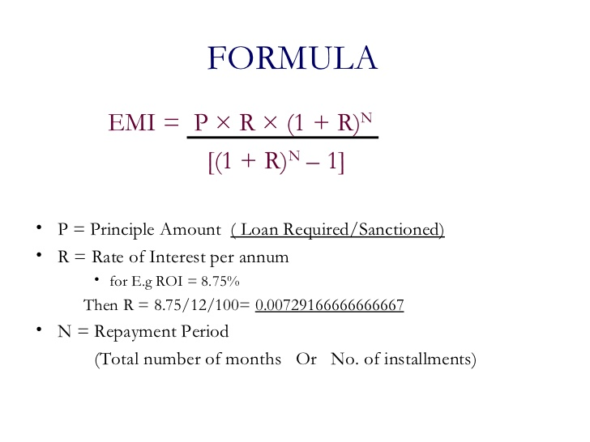

|  |  |  |
| --- | --- | --- |
| **NO** | **LOAN TERM** | **TOTAL** |
| 1. | Principal | Rm 249,000 |
| 2. | Interest rate  3.80 / 12 / 100 | 3.80 / 12 /100  0.00031 |
| 3. | Term of years  Years * 12 | 30 * 12  360 years |
| 4. | Monthly payment  249,000 * 0.31(1+ 0.31) * 30 years  (1+ 0.31) 30 years - 1 | Rm 1160 |
| 5. | Total Payment in contract  Total monthly payment * term of years * 12 | Rm 417,684 |
| 6 | The monthly payment house price  House price / 200 | Rm 130000/200  = Rm 650 |
| 7 | 1. Statement   249,000 * 0.31(1+ 0.31) * 30 years  (1+ 0.31) 30 years - 1  totalpayment = monthlypayment * years  yearlypayment = monthlypayment * 12 | Rm 1160  Rm1160 * 360  Rm 417600 * 12  Rm 5371200 |
|  | allpayment = yearlypayment * ((i+1)*12) |  |

1. **Evaluate the solution**

In the end of this system will help the borrower budget planning to buy a house because they already know how much the total they need to payment. This also make a borrower feel save to apply loan to the bank. Next the system will help the user to choice the house package according with the amount of budget that their want.this can make the user know which house that their can afford to buy. Last the system will help to borrower to see a payment statement from of the first years until the last of the loan years .

1. **Algorithm**
2. User need to choose option given.
3. Choose option 1 for register as new user.
4. Insert user full name, account number and phone number.
5. User become a new member of Maybank housing loan system.
6. User need to choose option given.
7. Choose option 2 for loan calculator
8. Insert user name, loan amount, interest rate and the number of years.
9. Wait until programme finish calculate total amount and monthly payment.
10. Programme display total amount and monthly payment.
11. User need to choose option given.
12. Choose option 3 for type of house.
13. User need to declare the budget.
14. The system will display type of house suitable if the budget.
15. Choose option 4 for E-Statement.
16. User need to input loan amount, interest rate, the number of years
17. The system will calculate the total of amount that user pay for the first year until the last years.
18. Choose option 5 for exit.
19. User exit the system.

**8.Pseudocode**

start

read choose

switch(choose)

case 1:

String [] housingloan=**null** ;

*Register* (housingloan);

break;

case 2:

Object loancalculator=**null**;

*calculator*(loancalculator);

break;

case 3:

String[] housetype = **null**;

*House*(housetype)

break;

case 4:

*futurehousevalue*()

Break;

Case 5:

String exit =**null**;

*exitSystem*()

Break;

while (choose != 5)

End

Method Register(Housingloan)

declare name array size = 15

declare acc_number array size = 15

declare phone_number array size = 10

initialize a = 1

read name,acc_number,phone_number

end

method calculator (loancalculator)

Declare name

Declare interest rate

Declear number of years

Read name

Read interest rate

Read number of years

Calculate monthly payment

Calculate total payment

end

method house(housetype)

Declare budget

Calculate the budget

Display house

End

Menthod futurehousevalue()

Declare loan amount

Declare interest rate

Declare number of years

Read name

Read interest rate

Read number of years

Calculate the total payment

End

Method exitSystem ()

End

End

1. Flowchart
2. **Flowchart**

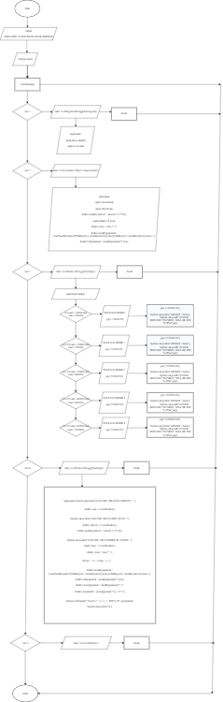

1. **Coding**

|  |
| --- |
| **package** Assingment3;  **import** java.util.Scanner;  **public** **class** codingYasri {    **static** Scanner *sc* = **new** Scanner (System.***in***);    **public** **static** **void** main(String[] args) {    // **TODO** Auto-generated method stub    System.***out***.println("------------------------------------- \n");  System.***out***.println("\n WELCOME TO MAYBANK BANK BERHAD \n");  System.***out***.println("------------------------------------- \n");    **int** menu;    **do** {    System.***out***.println("\nMENU");  System.***out***.println("\n1. REGISTER ");  System.***out***.println("\n2. LOAN CALCULATOR ");  System.***out***.println("\n3. TYPE HOUSE ");  System.***out***.println("\n4. E-STATEMENT ");  System.***out***.println("\n5. EXIT ");  System.***out***.print("\nSELECT CHOOSE: ");  menu = *sc*.nextInt();        **int** i;    **int** formatter = 0;    **switch** (menu)    {    **case** 1:    String [] housingloan=**null** ;    *Register* (housingloan);    **break**;    **case** 2:    Object loancalculator=**null**;    *calculator*(loancalculator);    **break**;    **case** 3:    String[] housetype = **null**;    *House*(housetype);    **break**;    **case** 4:    *futurehousevalue*();    **break**;    **case** 5:    String exit =**null**;    *exitSystem*();    **break**;      }      }**while** (menu != 5);    }    **static** **void** Register(String[] housingloan) {      Scanner scan = **new** Scanner (System.***in***);    String [] name = **new** String[15];    **int** [] phone_number = **new** **int**[10];    String [] acc_number = **new** String[15];    **int** a = 1;      System.***out***.print(" \n PLEASE ENTER YOUR NAME: ");    name [a]= scan.next();    scan.nextLine();    System.***out***.print(" \n PLEASE ENTER YOUR PHONE NUMBER : ");    phone_number[a] =scan.nextInt();      System.***out***.print(" \n PLEASE ENTER YOUR ACCOUNT NUMBER: ");    acc_number [a]= scan.next();      }    **static** **void** calculator (Object loancalculator){      System.***out***.println("\nENTER YOUR NAME : ");    String name = *sc*.next();    System.***out***.println("\nENTER THE LOAN AMOUNT : ");    **double** loan =*sc*.nextDouble();    System.***out***.println("\nENTER THE INTERST RATE : ");    **double** interest = *sc*.nextDouble();    **double** monthlyinterest = interest /(12*100);    System.***out***.println("\nENTER THE NUMBER OF YEARS : ");    **double** time = *sc*.nextDouble();    **double** years = time * 12;    **double** monthlypayment= (loan*monthlyinterest*Math.*pow*(1+monthlyinterest,years))/(Math.*pow*(1+monthlyinterest,years)-1);    **double** totalpayment = monthlypayment * years;      System.***out***.println("\n*---YOUR TOTAL MONTHLY PAYMENT AND TOTAL PAYMENT---*");    System.***out***.println("\nTHE TOTAL MONTHLY PAYMENT IS RM "+ (Math.*round*(monthlypayment)));    System.***out***.println("\nTHE TOTAL PAYMENT IS RM " + (Math.*round*(totalpayment)));    System.***out***.println("\n*THANK YOU FOR USING MAYBANK CALCULATOR *");    }      **static** **void** House (String [] housetype) {      String home="";    **int** loan;    **float** pay;        System.***out***.print("\nPLEASE ENTER YOUR BUDGET PRICE :");    loan=(**int**)*sc*.nextDouble();        **if**(loan>=100000 && loan<=200000){  home="1";  pay=130000/200;  System.***out***.println("PACKAGE HOME 1 ");  System.***out***.println("APARTMENT");  System.***out***.println("PRICE RM 130000 ");  System.***out***.println("HOUSE LOAN 30 YEARS");      }      **else** **if** (loan>=200000 && loan<=300000){    home="2";  pay=270000/200;  System.***out***.println("PACKAGE HOME 2");  System.***out***.println("SINGLE STOREY ");  System.***out***.println("PRICE RM 270000 ");  System.***out***.println("HOUSE LOAN 30 YEARS ");      }      **else** **if** (loan>=300000 && loan<=400000) {    home="3";  pay=320000/200;  System.***out***.println("PACKAGE HOME 3");  System.***out***.println("DOUBLE STOREY ");  System.***out***.println("PRICE RM 320000 ");  System.***out***.println("HOUSE LOAN 30 YEARS ");      }      **else** **if** (loan>=400000 && loan<=600000) {    home="4";  pay=550000/200;  System.***out***.println("PACKAGE HOME 4");  System.***out***.println("SEMI D DOUBLE STOREY ");  System.***out***.println("PRICE RM 550000 ");  System.***out***.println("HOUSE LOAN 30 YEARS ");      }      **else** **if** (loan>=600000 && loan<=1000000) {    home="5";  pay=1000000/200;  System.***out***.println("PACKAGE HOME 5");  System.***out***.println("BUNGLOW");  System.***out***.println("PRICE RM 1000000 ");  System.***out***.println("HOUSE LOAN 30 YEARS ");    }    System.***out***.print("\n***");    System.***out***.print("\nPLEASE ENTER PACKAGE NUMBER IF YOU INTERESETED : ");    home=*sc*.next();    home.toUpperCase();    **if**(home.equalsIgnoreCase(home)){    **switch**(home){      **case** "1":    pay=(130000/200);    System.***out***.println("\nPAKEJ "+home);  System.***out***.printf("\nYOUR MONTHLY PAYMENT WILL BE :RM %.2f%n",pay);    **break**;      **case** "2":    pay=(270000/200);    System.***out***.println("\nPAKEJ "+home);  System.***out***.printf("\nYOUR MONTHLY PAYMENT WILL BE :RM %.2f%n",pay);    **break**;      **case** "3":    pay=(320000/200);    System.***out***.println("\nPAKEJ "+home);  System.***out***.printf("\nYOUR MONTHLY PAYMENT WILL BE :RM %.2f%n",pay);    **break**;      **case** "4":    pay=(550000/200);    System.***out***.println("\nPAKEJ "+home);  System.***out***.printf("\nYOUR MONTHLY PAYMENT WILL BE :RM %.2f%n",pay);    **break**;      **case** "5":    pay=(1000000/200);    System.***out***.println("\nPAKEJ "+home);  System.***out***.printf("\nYOUR MONTHLY PAYMENT WILL BE :RM %.2f%n",pay);    **break**;    }    }    }      **static** **void** futurehousevalue(){      System.***out***.println("\nENTER THE LOAN AMOUNT : ");      **double** loan =*sc*.nextDouble();      System.***out***.println("\nENTER THE INTERST RATE : ");    **double** interest = *sc*.nextDouble();    **double** monthlyinterest = interest /(12*100);    System.***out***.println("\nENTER THE NUMBER OF YEARS : ");    **double** time = *sc*.nextDouble();    **double** years = time * 12;      **for**(**int** i = 0; i < time; i++) {      **double** monthlypayment = (loan*monthlyinterest*Math.*pow*(1+monthlyinterest,years))/(Math.*pow*(1+monthlyinterest,years)-1);    **double** totalpayment = monthlypayment * years;    **double** yearlypayment = monthlypayment * 12;    **double** allpayment = yearlypayment * ((i+1)*12);      System.***out***.format(" Year No "+ (i+1) +" : RM %.2f", allpayment);    System.***out***.println("\n");          }      }    **static** **void** exitSystem () {        System.***out***.println("\n************************************************");    System.***out***.println("\nTHANK YOU FOR USING OUR SERVICE. SEE YOU AGAIN! ");    System.***out***.println("\n************************************************");      }      } |

Output

|  |
| --- |
| -------------------------------------  WELCOME TO MAYBANK BANK BERHAD  -------------------------------------  MENU  1. REGISTER  2. LOAN CALCULATOR  3. TYPE HOUSE  4. E-STATEMENT  5. EXIT  SELECT CHOOSE: 1    PLEASE ENTER YOUR NAME: MUHAMMAD YASRI BIN ROSLAN    PLEASE ENTER YOUR PHONE NUMBER : 011234568    PLEASE ENTER YOUR ACCOUNT NUMBER: 326235654  MENU  1. REGISTER  2. LOAN CALCULATOR  3. TYPE HOUSE  4. E-STATEMENT  5. EXIT  SELECT CHOOSE: 2  ENTER YOUR NAME :  YASRI  ENTER THE LOAN AMOUNT :  249000  ENTER THE INTERST RATE :  3.80  ENTER THE NUMBER OF YEARS :  30  *---YOUR TOTAL MONTHLY PAYMENT AND TOTAL PAYMENT---*  THE TOTAL MONTHLY PAYMENT IS RM 1160  THE TOTAL PAYMENT IS RM 417684  *THANK YOU FOR USING MAYBANK CALCULATOR *  MENU  1. REGISTER  2. LOAN CALCULATOR  3. TYPE HOUSE  4. E-STATEMENT  5. EXIT  SELECT CHOOSE: 3  PLEASE ENTER YOUR BUDGET PRICE :300000  PACKAGE HOME 2  SINGLE STOREY  PRICE RM 270000  HOUSE LOAN 30 YEARS  ***  PLEASE ENTER PACKAGE NUMBER IF YOU INTERESETED : 2  PAKEJ 2  YOUR MONTHLY PAYMENT WILL BE :RM 1350.00  MENU  1. REGISTER  2. LOAN CALCULATOR  3. TYPE HOUSE  4. E-STATEMENT  5. EXIT  SELECT CHOOSE: 4  ENTER THE LOAN AMOUNT :  249000  ENTER THE INTERST RATE :  3.80  ENTER THE NUMBER OF YEARS :  30  Year No 1 : RM 167073.67  Year No 2 : RM 334147.34  Year No 3 : RM 501221.00  Year No 4 : RM 668294.67  Year No 5 : RM 835368.34  Year No 6 : RM 1002442.01  Year No 7 : RM 1169515.67  Year No 8 : RM 1336589.34  Year No 9 : RM 1503663.01  Year No 10 : RM 1670736.68  Year No 11 : RM 1837810.35  Year No 12 : RM 2004884.01  Year No 13 : RM 2171957.68  Year No 14 : RM 2339031.35  Year No 15 : RM 2506105.02  Year No 16 : RM 2673178.68  Year No 17 : RM 2840252.35  Year No 18 : RM 3007326.02  Year No 19 : RM 3174399.69  Year No 20 : RM 3341473.36  Year No 21 : RM 3508547.02  Year No 22 : RM 3675620.69  Year No 23 : RM 3842694.36  Year No 24 : RM 4009768.03  Year No 25 : RM 4176841.69  Year No 26 : RM 4343915.36  Year No 27 : RM 4510989.03  Year No 28 : RM 4678062.70  Year No 29 : RM 4845136.37  Year No 30 : RM 5012210.03  MENU  1. REGISTER  2. LOAN CALCULATOR  3. TYPE HOUSE  4. E-STATEMENT  5. EXIT  SELECT CHOOSE: 5  ************************************************  THANK YOU FOR USING OUR SERVICE. SEE YOU AGAIN!  ************************************************ |



**A211 STIA1113 – PROGRAMMING 1 (GROUP C)**

**ASSIGNMENT 3**

**NAME: MUHAMAD AIMIL DANIEL BIN LATIF**

**MATRIC NUMBER: 287056**

**TOPIC: BANK**

**SUBTOPIC: INVESTMENT**

**LECTURER: PROF. MADYA DR. AZMAN B YASIN**

**DUE DATE: 29 JANUARY 2022**

1. **Identify the Problem**

Regarding from assignment 1 and 2, the problem is still same which is to find other alternative to expand money. However, for now, they want to know to know the process amount of investment per month.

1. **Understand the problem**

From the problem, the customer or investors wants to know the exactly amount per month they will receive and at the same time, to simplify the process.

1. **List Instructions that Enable you to Solve the Problem Using the Selected Solution**
   1. Display Main Menu.
   2. Ask user to key in their name, number phone and account number.
   3. Enter Investment Amount and Investment Tenure.
   4. Wait for the system to calculate the amount of profitability.
   5. System will display the name, number phone, account number, profit payable to the Customer, accumulated profits and total amount.
   6. System will list the amount of money from investment depends on investment tenure.
   7. Exit system.
2. **Evaluate the Solution**

From this, the system will help the both side which is from investors sides and bank sides. For investor, they do not have to key in percentage of net return to customer anymore. Hence, the system will ease the user since the menu of system seems like given instruction to the user.

1. **ALGORITHM**

1. Start

2. Enter name, phone number, account number.

4. Enter investment amount, investment tenure.

5. System calculate the input.

6. Display customer name, phone number, account number, profit payable to cust, accumulated profits and total amount.

8. Display future value of investment.

9. Exit system.

10. End

1. **PSEUDOCODE**

Start

do {

main menu

case 1 = Register

Input name

Input phone_number

Input acc_number

case 2 = Invesment Amount

Input invest_amount

Input invest_tenure

do {

percent = 0

if((invest_amount >= 1000)&&(invest_amount <= 10000))

percent =3.2

else if((invest_amount >= 100001)&&(invest_amount <= 30000))

percent =3.8

else if((invest_amount >= 300001)&&(invest_amount <= 50000))

percent =4

else if ((invest_amount < 1000)&&(invest_amount>50000)

PLEASE PUT AMOUNT BETWEEN RM1000 TO RM50000

} while (invest_amount < 1000)||(invest_amount>50000)

profitpayabletocust = invest_amount * percent/100 * 30/365

accumulatedprofit = profitpayabletocust * invest_tenure

totalamount = invest_amount + accumulatedprofit

Output "NAME" + name

Output "PHONE NUMBER” + phone_number

Output "ACCOUNT NUMBER" + Account Number

Output "PROFIT PAYABLE TO CUSTOMER"+ profitpayabletocust

Output "ACCUMULATED PROFIT" + accumulatedprofit

Output "TOTAL AMOUNT" + totalamount

case 3 = future investment value

profitpayabletocust = invest_amount * percent/100 * 30/365

accumulatedprofit = profitpayabletocust * (i+1)

totalamount = invest_amount + accumulatedprofit

MonthNo + (i+1) + totalamount

case 4 = exit system

THANK YOU FOR USING OUR SERVICE. SEE YOU AGAIN!

}

While( choose != 4)

End

1. **FLOWCHART**
2. 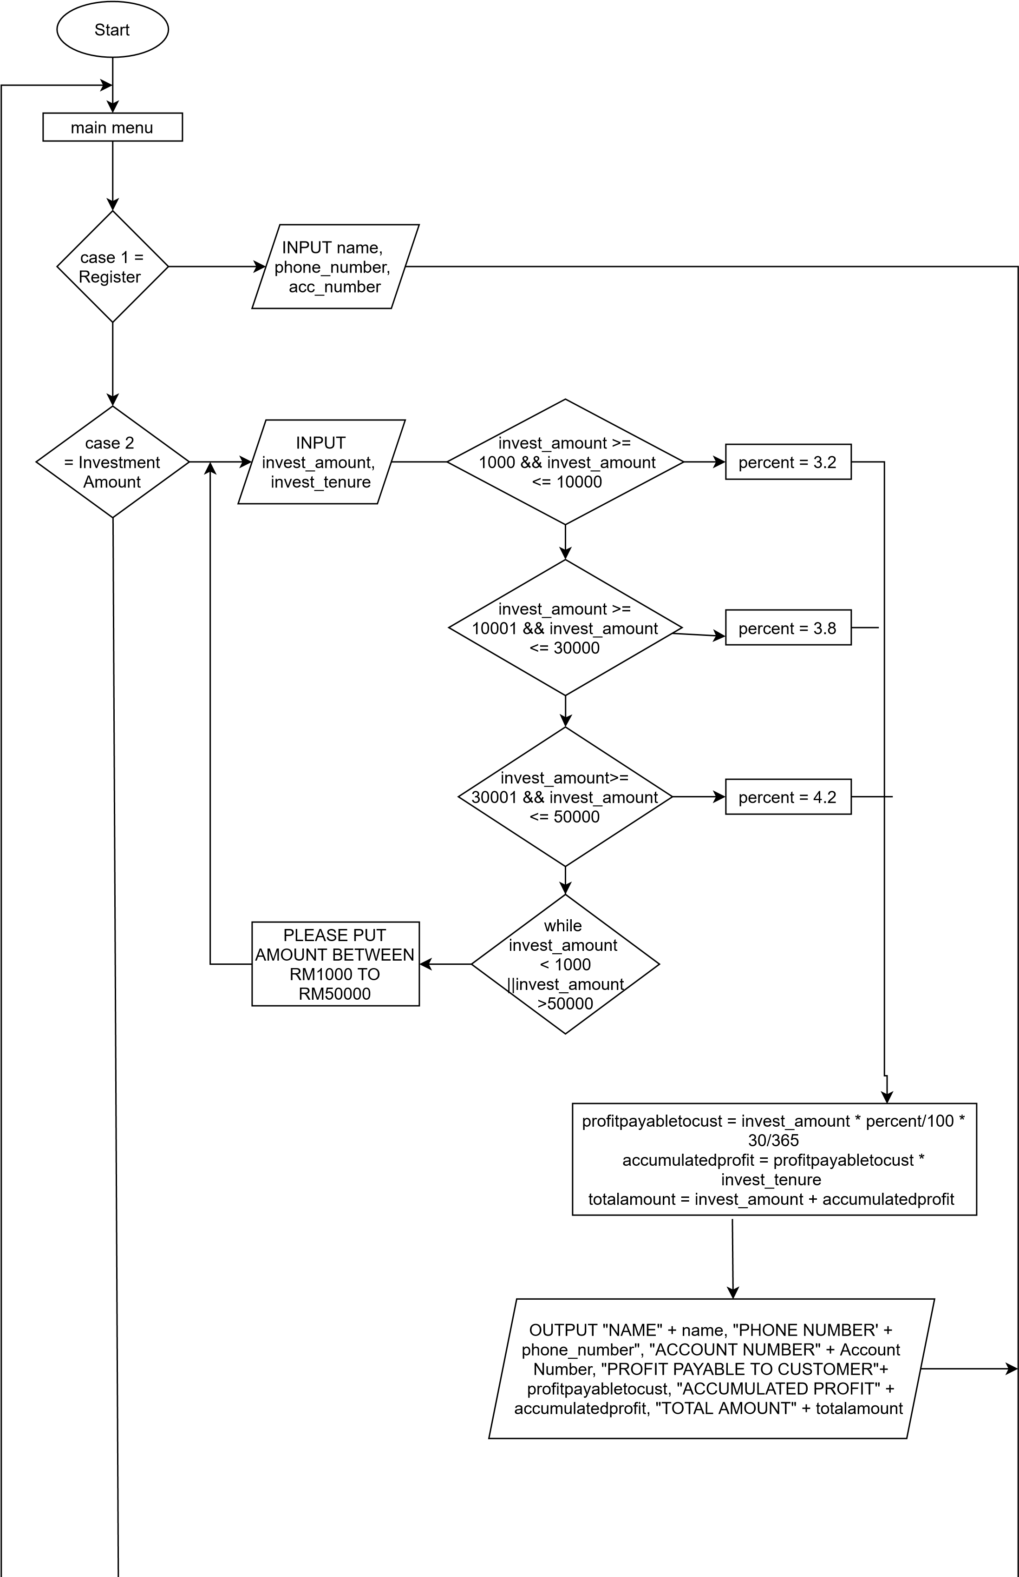

case 3

future

=

Investment

value

case 4

exit

=

System

while

choose

4

!=

profitpayabletocust = invest_amount

* percent/100 * 30/365

accumulatedprofit =

profitpayabletocust * (i+1)

totalamount = invest_amount

+

accumulatedprofit

THANK YOU FOR USING OUR

SERVICE. SEE YOU AGAIN!

END

Month No + (i+1)+

totalamount

**8. Coding – Numerical Computation & Expression**

